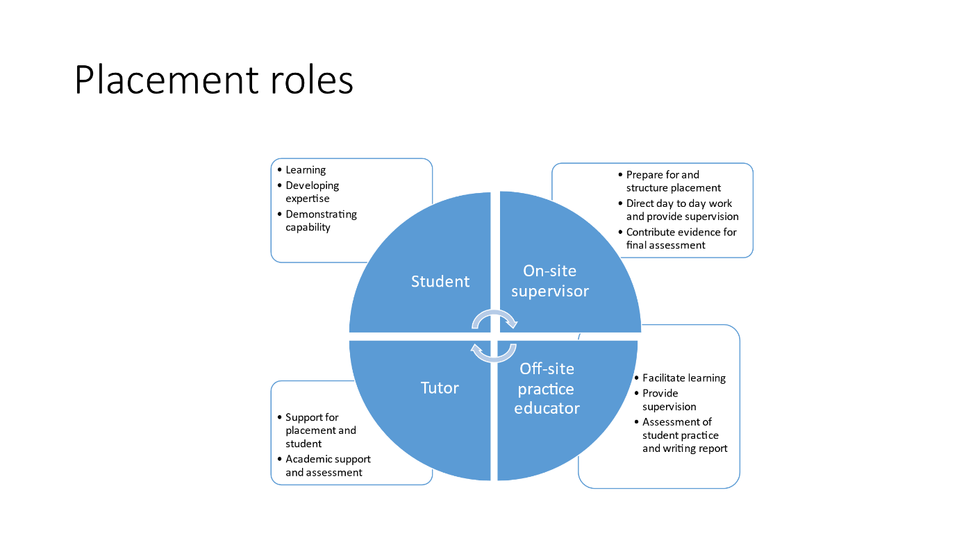

The OSS will see the student the most in the placement journey. They prepare for the student arriving, structure the placement so that they understand the role, the agency etc. The OSS will be there for day-to-day support and direction, providing supervision for the cases that they are working with – the practical things of what they need to do next, who do they contact etc. The OSS will also contribute evidence to the final assessment of the student.

The Offsite PE will also help facilitate learning of the student, and they will provide supervision as well. Their supervision will focus more on social work theory, links to legislation, PCF domains etc. The PE is responsible for the overall assessment of the students practice and writing the final report for the student, taking into account the OSS’s contribution as well.