Social Graces

*John Burnham et al (2012) developed the acronym* ***‘social grraaccceeesss’*** *to represent aspects of difference in beliefs, power and lifestyle, visible and invisible, voiced and unvoiced, to which we might pay attention in supervision.*

*It is a guide to consider the interacting factors that can inform identity and power and to consider the uniqueness of each person and consider how this interacts within the supervisory relationship. They are useful in reminding and making named, some of the possible unique differences to be considered about ‘otherness’.*

*The* ***social grraaccceeesss*** *is a framework for considering further aspects of diversity and difference.*

**See the exercise below taken for the PE training programme**. You might want to use the 'social graces' exercise below, in an early supervision session with your student, to consider and discuss aspects of difference in beliefs, power and lifestyle, visible and invisible, voiced and unvoiced.

The purpose of this discussion is for students and their supervisors to reflect on how their own unique background has impacted/influenced their relationship with supervisors, colleagues, service users and carers.

How might a student from a more/less “privileged” or different background be perceived and how would they acknowledge these power differentials and support the student so that they are not disadvantaged.

How can the supervisory relationship promote a greater understanding and appreciation of these differences in an effort to minimise the power differentials?

So…….

What unique contribution might the student make to the placement?

What personal barriers might the student experience?

What might be the impact of both on them?

What is the impact on the PE - student relationship?

What is the PEs role in combatting these barriers?

12

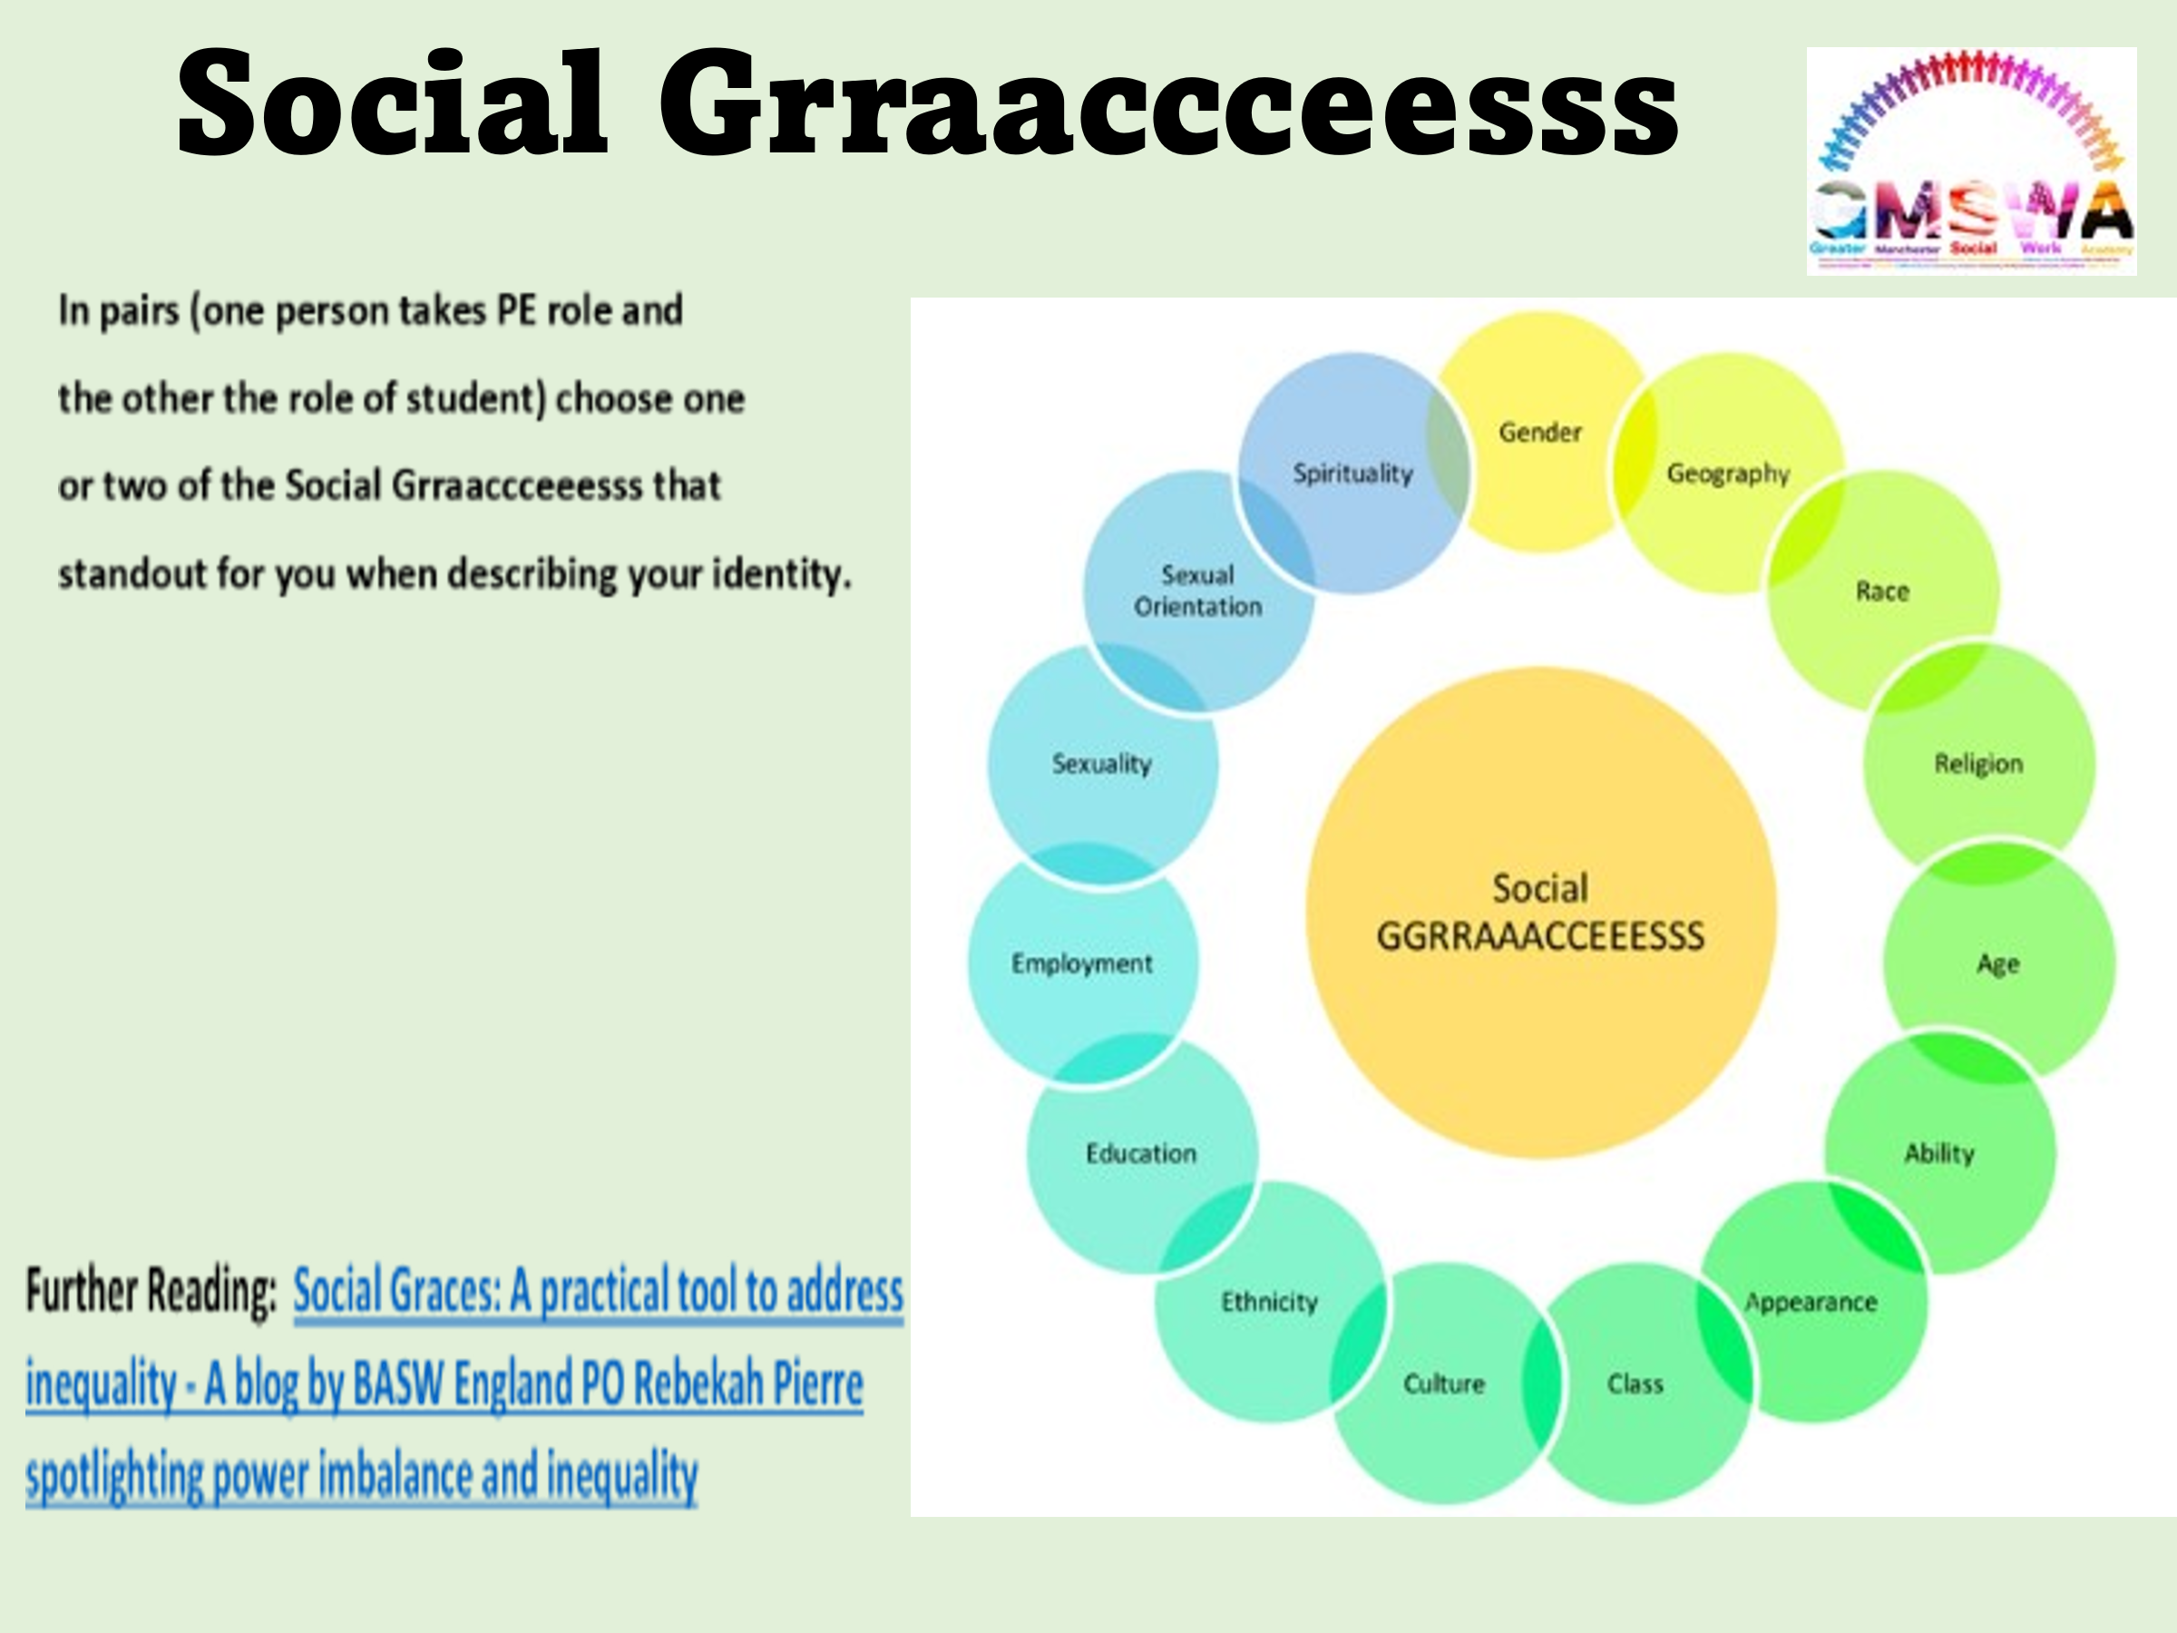

13

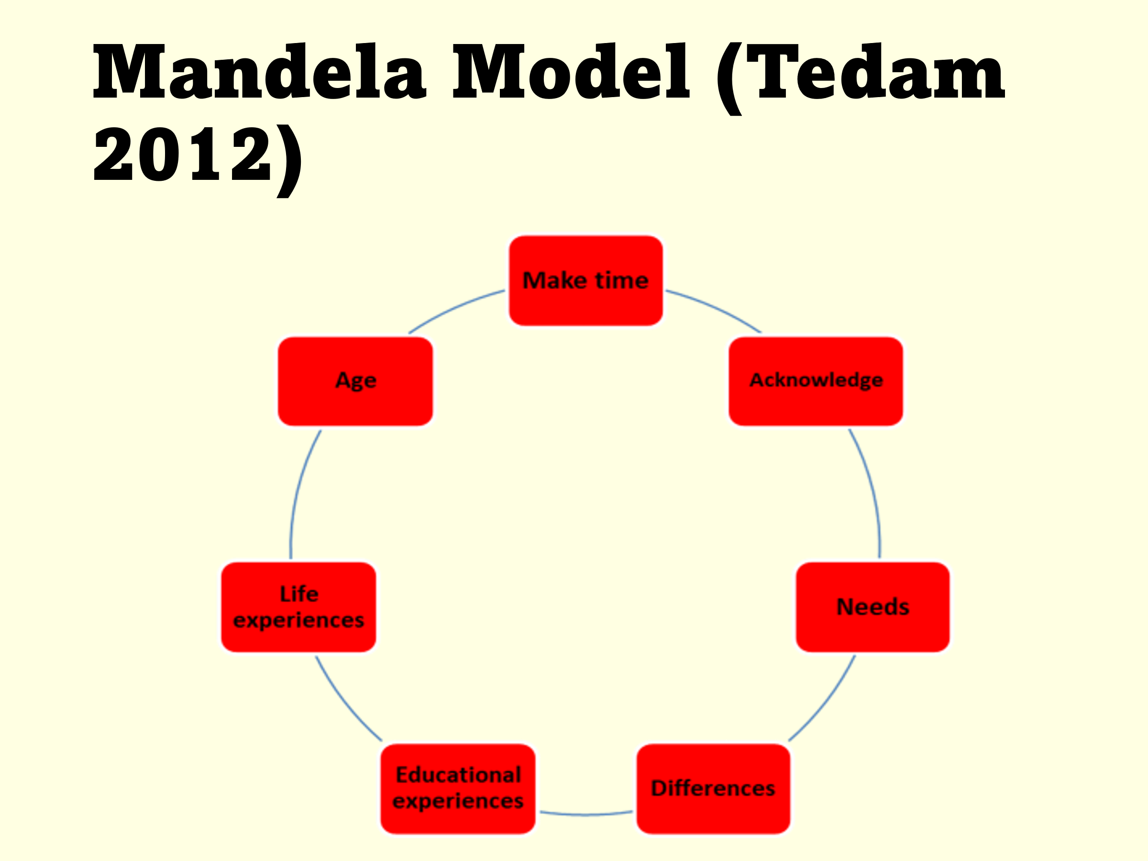

The MANDELA model is not only applicable and helpful for practice educators and Black African students. It gives permission for important areas to be discussed and also offers suggestions and guidance that is helpful to encourage anti oppressive practice, therefore it is suitable for all practice educators engaging all students.

**Make time -** Do not fast track the student into difficulty or failing. Ensure student has sufficient time to understand context and nature of the work. Make time for supervision at the pace of the student.

**Acknowledge Needs -** Specify any needs – English language proficiency, general communication skills, written skills, report writing needs etc. Consider how to address these needs. Consider from the student’s perspective.

**Difference -** After consideration of needs, issues of difference and similarity can be explored. Not simply about ethnic or cultural similarities or differences, may be gender. Consider from the student’s perspective.

**Educational experience -** Discuss **preferred learning style** and comfort with written skills for different purposes and spoken English.

**Life experiences -** Recognise importance of life experience and what the student brings.

Can be explored but can be a sensitive area, caution advised.

**Age -** Within African contexts, age / generation is an important variable in understanding relationships and interactions. Age/generational issues may be important with other students.