**Your students Induction and what you need to do**

**Planning – Prior to Student starting placement**

Hopefully the informal pre-placement meeting with the student was productive and the areas below were discussed and shared. If any of the areas below were not considered make sure you raise them on the first day of placement or as soon as possible.

**During the Pre-placement visit**

**Discuss**

* your background and SW experience
* the students background, prior learning, experience, learning needs and expectations
* the teams’ role and function as well as team cultures, expectations etc.
* practical arrangements e.g., availability of desk, phone, computer, tea fund etc.
* time keeping, your expectations of arrival and departure - does the student have different expectations
* student’s personal issues e.g. caring responsibilities that might impact upon the placement, any conflict of interests, disability and health needs
* your expectations of the placement, including dress code, boundaries, confidentiality, mobile phones, use of face book etc.
* the supervision process
* concerns, questions, issues you or the student might have

**Practicalities before the student starts placement**

* Make sure you have organised outlook, liquid logic, mobile phone, laptop, cotag etc. ahead of time. Also any training you would want the student to attend.
* Inform the student of first day arrangements i.e. what time / whom to meet.
* Have you prepared your team for the student and decided how are they going to be introduced? Make sure the student attends any meetings.
* Have you discussed your workload with your manager and how your students work will be managed and allocated? Will there be any workload relief for you, in acknowledgement, of you supervising your student?
* Organise a ‘Buddy’ for the student to connect with when you are not around
* Identify other PEs who are going to be taking students and explore whether any aspects of Induction can be joined up
* Think about planning in some swapping or shadowing activities to give the student an idea of services across the organisation.

**2**

**Where will the student be based?**

* Will there be a combination of working between office/building and home?
* If the student has a health condition /disability - does this need to be considered?
* Is working at home viable with the student i.e. quiet space, confidentiality issues? Will it be constructive?
* Will the student receive daily support and what will this look like?
* Are there opportunities for regular team reflective discussions? How is the student going to learn from others?

**How will work be allocated to the student**

* Who will be responsible for giving work to the student and how will this be done?
* How will work be monitored, reviewed, and managed?
* How will observational/shadowing opportunities take place?
* To protect the student and allow for reflection and learning to take place they must have no more than half the caseload (50%) of an experienced qualified social worker by end of placement

**Student Induction Day 1**

* Learning Agreement contract meeting with tutor (if not already taken place)
* Agree how student will evidence work, especially completed at home, a daily log may be appropriate and use of calendar.
* Introduction to the team – this might be virtual using a pre-arranged team meeting
* Tour of building with health and safety/fire and Covid 19 building regulations shared
* Discuss practical (mindful of Covid 19 regulations) arrangements e.g. Car parking, tea, coffee, lunch arrangements, standards and approach, dress code, health and safety, absence procedure, relevant reading, training, day to day duties of the team
* Give PPE if appropriate or discuss how to access
* Show student where they can access Key policies and procedures for example: GDPR, Confidentiality, Data protection, Valuing Diversity, Grievance/Disciplinary/anti-harassment/whistleblowing
* Make sure student has the **Social Work Student Welcome Pack** which includes the student workshops

**3**

**Student induction Day 1 - 5**

**There may be other activities you want to arrange however these are the minimum expectations for week one**

* Diary all supervision sessions for whole of placement.
* If applicable Supervision sessions with Off-site PE to be set up
* [Tool 1: Exploring expectations in the supervisory relationship](https://boltoncouncilcloud.sharepoint.com/:w:/r/sites/cspprspo/CSC/_layouts/15/Doc.aspx?sourcedoc=%7B041B80D1-6377-408F-A317-1542D73A2C93%7D&file=Tool%201%20Exploring%20expectations%20in%20the%20supervisory%20relationship.docx&action=default&mobileredirect=true)

This tool enables you to promote discussion and explore expectations and helps you both understand each other’s expectations of supervision in order to draw up a supervision agreement

* Complete the supervision agreement. [Tool 2: Supervision contract discussion](https://boltoncouncilcloud.sharepoint.com/:w:/r/sites/cspprspo/CSC/_layouts/15/Doc.aspx?sourcedoc=%7B263C9A41-BF99-4A54-9743-9635021145AE%7D&file=Tool%202%20Supervision%20Contract%20Discussion.docx&action=default&mobileredirect=true)
* Discuss and agree process for booking flexi time, leave, study time etc.
* Give student list of training and student support sessions (see student welcome pack) , access to ME Learning **Research in Practice** resources discussed  **To set up an account follow the instructions** [**here**](https://www.researchinpractice.org.uk/register/)
* Arrange (virtual if necessary) visits/shadowing for the student to other teams, settings or to meet and observe other professionals
* Student to obtain I.D badge
* Give clear guidelines about: working from home, safety on visits (lone working / safeguarding) & confidentiality.

**Student induction First Month in Placement**

**There may be other activities you want to arrange however these are the minimum expectations for the first month**

* Further visits to other teams, agencies and individuals arranged if appropriate
* It is recommended that students are based in your office/building at the beginning weeks of placement in order to observe/support duty and learn from being around other practitioners. Thereafter, agree arrangements for hybrid working

* At least four shadowing opportunities with practitioners to be arranged (expectation that students will reflect on shadowing opportunities during supervision)
* Complete any ME learning identified modules
* Arrange Co-working opportunities and case work/direct work for student
* Weekly reflective supervision with PE should be taking place with daily check in support from PE/team manager or member of the team
* Pay due attention to how emails are being used to communicate. Confidentiality via email needs clarifying as a data breach can occur if information is sent to the wrong person

**4**

**5**

## Allocation and Induction

How will you manage the allocation of work to the student? Who has the power of allocation in your team?

Using the diagram below and the grid on the next page, think about each component of the induction programme for your setting and make a note of the things you want the student to do. Try to be specific – for example, which key people do they need to meet or which policies do they need to read?

**Meeting key people**

**Practical arrangements**

**Placement routines**

**Introduction**

**Policies and procedures**

**Establishing the supervisory relationship**

**Preparation for direct contact with service users**

|  |  |
| --- | --- |
| **Induction Task** | **Comments** |
| Meet key people |  |
| Practical arrangements |  |
| Placement routines |  |
| Policies and procedures |  |
| Establishing a supervisory relationship |  |
| Preparation for direct contact with service users |  |

11

Social Graces

*John Burnham et al (2012) developed the acronym* ***‘social grraaccceeesss’*** *to represent aspects of difference in beliefs, power and lifestyle, visible and invisible, voiced and unvoiced, to which we might pay attention in supervision.*

*It is a guide to consider the interacting factors that can inform identity and power and to consider the uniqueness of each person and consider how this interacts within the supervisory relationship. They are useful in reminding and making named, some of the possible unique differences to be considered about ‘otherness’.*

*The* ***social grraaccceeesss*** *is a framework for considering further aspects of diversity and difference.*

**See the exercise below taken for the PE training programme**. You might want to use the 'social graces' exercise below, in an early supervision session with your student, to consider and discuss aspects of difference in beliefs, power and lifestyle, visible and invisible, voiced and unvoiced.

The purpose of this discussion is for students and their supervisors to reflect on how their own unique background has impacted/influenced their relationship with supervisors, colleagues, service users and carers.

How might a student from a more/less “privileged” or different background be perceived and how would they acknowledge these power differentials and support the student so that they are not disadvantaged.

How can the supervisory relationship promote a greater understanding and appreciation of these differences in an effort to minimise the power differentials?

So…….

What unique contribution might the student make to the placement?

What personal barriers might the student experience?

What might be the impact of both on them?

What is the impact on the PE - student relationship?

What is the PEs role in combatting these barriers?

12

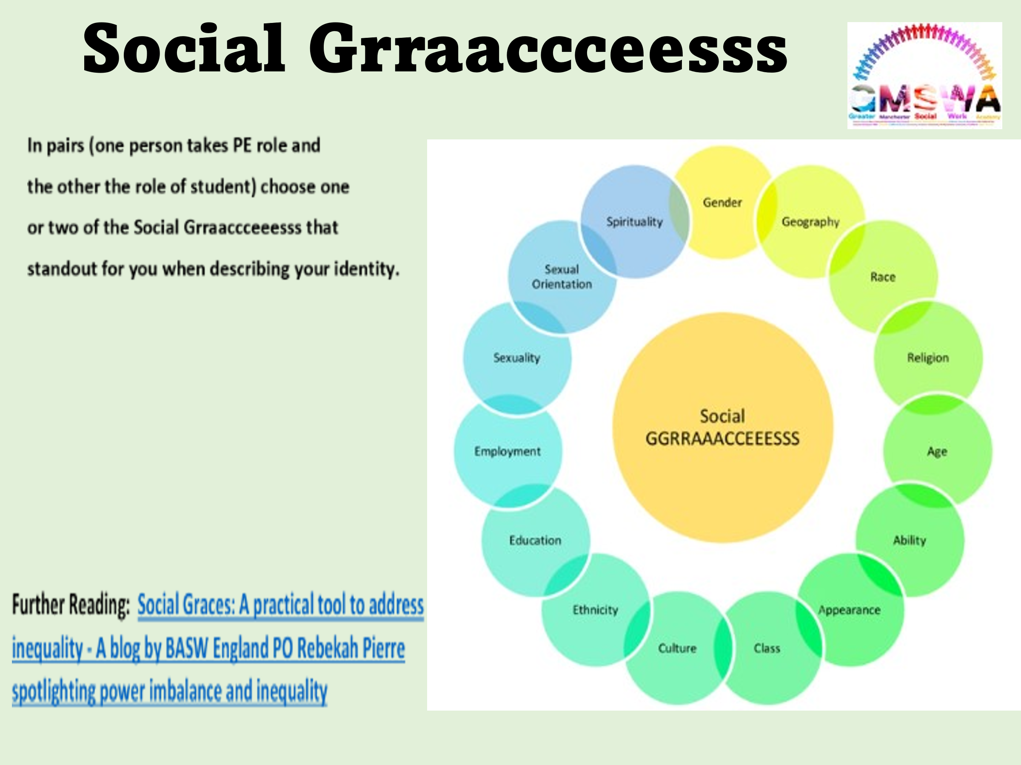

13

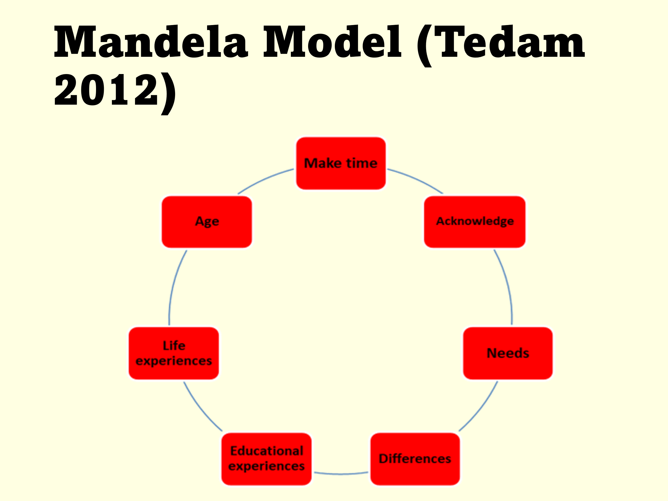

The MANDELA model is not only applicable and helpful for practice educators and Black African students. It gives permission for important areas to be discussed and also offers suggestions and guidance that is helpful to encourage anti oppressive practice, therefore it is suitable for all practice educators engaging all students.

**Make time -** Do not fast track the student into difficulty or failing. Ensure student has sufficient time to understand context and nature of the work. Make time for supervision at the pace of the student.

**Acknowledge Needs -** Specify any needs – English language proficiency, general communication skills, written skills, report writing needs etc. Consider how to address these needs. Consider from the student’s perspective.

**Difference -** After consideration of needs, issues of difference and similarity can be explored. Not simply about ethnic or cultural similarities or differences, may be gender. Consider from the student’s perspective.

**Educational experience -** Discuss **preferred learning style** and comfort with written skills for different purposes and spoken English.

**Life experiences -** Recognise importance of life experience and what the student brings.

Can be explored but can be a sensitive area, caution advised.

**Age -** Within African contexts, age / generation is an important variable in understanding relationships and interactions. Age/generational issues may be important with other students.