

Social Work Student Welcome Pack

Salford Adults





|  |
| --- |
| **Contents** |

Section 1 – Message from the Principal Social Worker…………………………………3

Section 2 – Introduction…………………………………………………………………….4

Section 3 – Salford …………………………………………………………………………5

Section 4 – Context and Organisation…………………………………………………….7

Section 5 – Equality, Diversity and Inclusion……………………………………………..9

Section 6 – Local information……………………………………………………………..10

Section 6 – Social Work England (SWE)………………………...……………………….12

Section 7 – Professional Capabilities Framework (PCF)………………………….……13

Section 8 – Training and Development Opportunities………………………………....15

Section 9 – Policies, procedures, and practice guidance………………………...……19

Section 10 – Supervision……………………………………………………………….....20

Section 11 – Reflective Practice………………………………………………………….22

Section 12 – Student Well-being………………………………………………………….26

Section 13 – Useful information (FAQs)………………………………………………….28

Section 14 – Concerns……………………………………………………………………..33

**Abbreviations**……………………………………………………………………………..34

**Appendices**………………………………………………………………………………..35

**References**………………………………………………………………………………...35

|  |  |
| --- | --- |
| **1.** | **Message from the Salford Adults’ Principal Social Worker (PSW)** |

Welcome to Salford! We are glad to have you with us and we hope this will be the beginning of a successful and enjoyable career in social work for you.

As PSW I’m the professional lead for social work in adult social care. I want to support all our social workers, including our social work students.

I can remember the first time that I set foot in a social work office when I was a student. I was very nervous, but everyone was very welcoming and encouraging. I began to see myself in the role and think about how I might respond to the situations that the social workers were talking about. I hope that’s your experience too.

In becoming a social worker you’ll learn about human development, about ethics and human rights, oppression, and inclusion and many other things. But you’ll also use that learning to grow as a person, to be someone who can take on the responsibility of working with people in some of the most challenging situations of their lives.

As social workers we must step up, but we also have to acknowledge when we need help ourselves. Don’t suffer in silence – there’s always someone who can help you. Everyone wants you to do well - but remember that the only person who’s devoted full-time to your placement is you. Working out how to organise your time effectively and work productively are vital skills.

It takes time to learn all this, and to put your learning into practice with confidence. But with hard work and honest reflection you’ll get there. We have a great Learning and Development Team who will support you all the way and will help you resolve any difficulties you may have.

I run a monthly drop-in session to give everyone in the department the chance to speak to me and tell me what they think their PSW needs to hear. I hope to see you there.

Good luck! Martin



Martin Sexton

Principal Social Worker

Head of Social Work Standards Quality and Safeguarding

Salford Adult Social Care

Co-chair, ADASS national MCA/DOLS network

|  |  |
| --- | --- |
| **2.** | **Introduction** |

Welcome to Salford and we truly hope you have a fantastic experience here. This welcome pack has been developed to provide useful information about our services in Salford Adult Social Care (ASC) and contains resources that will be beneficial for you during placement.

Salford ASC offers a range of social work placements which are arranged in collaboration with our university partners in Greater Manchester. We offer a robust student induction, training, and development opportunities, along with monthly support groups, led by the social work development lead.

We are committed to ensuring you feel supported and have access to a diverse range of learning opportunities to help you build professional confidence and bring your theory-based learning into practice. This pack contains resources to help you understand the context of our organisation, requirements, guidelines, and options for practice learning. An inventory of contents covered in this pack can be found on page 2, along with addendum documents in the appendices.

This welcome pack includes reference to key social work national frameworks and standards including the:

* Social Work England Professional Standards (SWEPS) [Professional standards - Social Work England](https://www.socialworkengland.org.uk/standards/professional-standards/)
* British Association of Social Work (BASW) Professional Capabilities Framework (PCF) [Professional Capabilities Framework (PCF) | www.basw.co.uk](https://www.basw.co.uk/social-work-training/professional-capabilities-framework-pcf)
* BASW code of ethics

<https://new.basw.co.uk/sites/default/files/resources/basw_code_of_ethics_-_2021.pdf>

This welcome pack can be used by anyone involved with student learning, including On-Site Supervisors (OSS) and Practice Educators (PE). The pack is accessible to all social work staff employed by Salford City Council (SCC) and the Northern Care Alliance (NCA) Foundation Trust, including those working in Salford based Greater Manchester Mental Health (GMMH) teams. You will be provided a copy on commencement of placement either by your supervisor or the ASC Learning and Development team. Or a copy is downloadable through our staff information hub (more information included in section 9, p18). Please let us know if you need the formatting or colouring of the document to be changed or adapted, to meet your individual learning needs. A list of roles and responsibilities for key stakeholders during placement, can be found in **Appendix 1**.

Please note there are certain references to NCA policies, procedures, and internal systems; if your placement is based in a GMMH team, your supervisor will advise of the equivalent processes.

|  |  |
| --- | --- |
| **3.** | **Salford** |

**History of Salford**

As you are on placement in Salford, we hope you have opportunity to get to know the city better. Salford is a vibrant city with an interesting history, with the largest percentage increase population growth in the North West between 2011 and 2021. There are many places of cultural significance that are worth a visit, including Ordsall Hall, Salford Museum and Art Gallery, Salford Lads Club (as seen on The Smiths album cover The Queen Is Dead 1985), The Quays, Media City and Clifton Country Park.

Salford can be traced back to the Mesolithic age and developed during the Industrial Revolution with a growing textile industry. Gaining city status in 1926. Salford has suffered from high levels of unemployment, housing, and social problems since around the 1960s. After industrial decline in the 20th century, Salford has seen areas of regeneration since the 1990’s. Many notable companies, tourist attractions and establishments have been built in the city, such as the University of Salford and Lowry Centre. BBC North and Granada Television are now situated in Salford Quays. RHS Bridgewater is a stunning 156-acre RHS garden in the North West, on the site of Worsley New Hall estate. See [About Salford•Salford City Council](https://www.salford.gov.uk/people-communities-and-local-information/about-salford/) for more on Salford history. The map below shows an outline of neighbourhoods in our fantastic city.

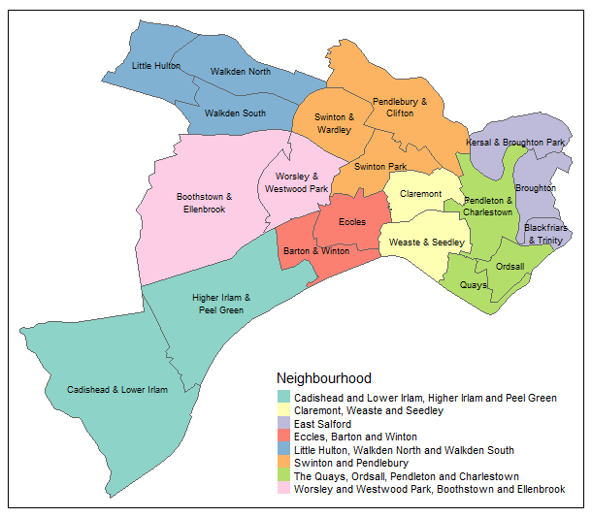

Some famous Salfordian’s you may know include: Dame Sarah Storey the most successful British Paralympian with medals in swimming and cycling, Wendy Tan-White MBE technology entrepreneur and investor, Benedict Wong actor whose starred in Hollywood blockbusters, LS Lowry Artist, Christopher Eccleston Actor who previously played as Doctor Who, John Cooper Clarke “punk poet” and comedian, and Emmeline Pankhurst co-founder of the Suffragette movement born in Moss Side, spent time living in Salford. Take a look at [Famous Salfordians•Salford City Council](https://www.salford.gov.uk/people-communities-and-local-information/famous-salfordians/) for more on Salfordian artists, writers, athletes, musicians and leaders.

**Population and Diversity of Salford** - Salford homes around 270,000 residents and continues to grow into an increasingly diverse and multi-cultural area. It is important that we understand our communities so that we can continue to be inclusive by responding to different needs.

The Equality Act 2010 provides the legal framework for statutory services and recognising diversity helps us to apply anti-oppressive principles in practice. Diversity is multidimensional including race, disability, class, economic status, age, sexuality, and gender (including transgender), faith and belief, and intersection of this and other characteristics. Being professionally curious about difference can truly help us to embrace strengths-based and person-centred approaches. More information about Salford’s diverse population can be found in **Appendix 2** and for further details on the demographic of Salford its worth reading 2021 census information via [How life has changed in Salford: Census 2021](https://www.ons.gov.uk/visualisations/censusareachanges/E08000006). Census information tells us more about employment levels, health status, disability, ethnicity, and numbers of unpaid carers in Salford, which helps us to understand and respond to the needs of our community.

The latest national census data also shows Salford is home to one of the largest Orthodox Jewish communities outside of London and other long-established communities such as the Yemeni, Pakistani, Bangladeshi and Gypsy, Roma Traveller communities. We celebrate the vibrant, growing, and intersectional population of Salford, and strive to create a culture of solidarity with our communities.



**Salford Adult Social Care vision**

In our organisation we hold we have a vision to work with communities and partners so every person can lead fulfilling, healthy, and independent lives. With a commitment:

* We will do whatever we can to help the people we work with to have the opportunity for a good quality of life in their community.
* We will create opportunities for people to maximise their independence and support their freedom of choice, assisting those at risk to achieve the safety they desire.
* We will focus our support to people on what is important to them - their strengths, connections, family, and communities. We will recognise the importance of their home and promote their rights while challenging discrimination.
* We will ensure that the values guiding our work with the people of Salford are the same values that support our working relationships within adult social care. We will treat everyone with respect.

**Appendix 2** has more information on our statement of standards and vision, which can help you to explore how you can be part of this during your time here.

|  |  |
| --- | --- |
| **4.** | **Context and organisation of Salford Adult Social Care (ASC)** |

Adult Social Care in Salford is part of the Northern Care Alliance (NCA) Foundation Trust and Greater Manchester Mental Health (GMMH) Trust, which means we are employed and work for the NHS. Adult Social Care in Salford used to be directly in Salford City Council until 2016, when health and care partners in Salford created Salford Integrated Care Organisation (SCO), with the NCA as the primary provider of health and social care in Salford. The Director of Adult Social Services (DASS) remains with Salford City Council which retains the statutory duties and responsibilities. However, the NCA and GMMH carry out the provision and operational delivery of Adult Social Care and Mental Health functions, on behalf of Salford City Council pursuant to a legal agreement, including assessments, case management and safeguarding. We are the only fully integrated organisation in Greater Manchester. You can visit the following websites to find out more about our organisation:

<https://www.northerncarealliance.nhs.uk/>

<https://www.salford.gov.uk/>

<https://www.gmmh.nhs.uk/>

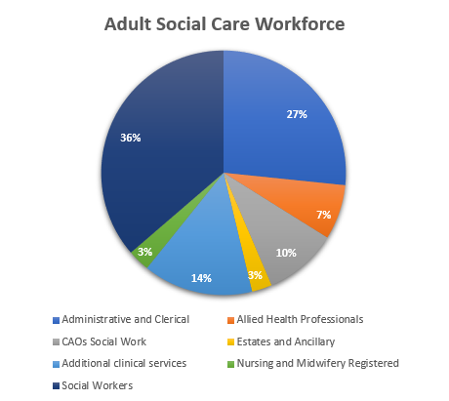

There are approximately 400 staff in several roles across the service. The Adult Social Care (ASC) workforce is made up of a variety of professionals who work in different settings in the Community and Hospital. We have statutory responsibilities under the Care Act 2014 to provide assessment and support to adults and carers (where eligible) in Salford, to help promote people’s independence, wellbeing, their outcomes, and safeguard to minimise the risk of harm.

A list of Adult Social Care and Mental Health teams includes –

* Later life Community Mental Health Teams (Older adults 65+)
* Community Mental Health Teams (Adults under 65)
* Forensic Social Work Team
* Integrated Neighbourhood Teams (Generic Adults)
* Review and Extra Care Teams (Including Residential/Nursing Care)
* Learning Disability Team
* Sensory Team
* Transition Team
* Adult Social Care Contact Team (Front door service)
* Hospital Social Work Team
* Hospital Social Work Team (Neuro)
* Intermediate Care Team (Rehabilitation following hospital stay)

We work closely with several non-social work teams, a few include, business support, care brokerage, finance, and procurement, who all play essential roles in supporting staff and the people of Salford. To find out more about our senior leadership team and our extensive range of teams, you can visit our information hub website [Adult Social Care Teams – Salford Adult Social Care Information Hub](https://www.salfordappp.co.uk/appp-professionals/appp-prof-asc/)

The primary key legal frameworks underpinning our statutory duties, legal interventions, and professional decision making include the:

* Care Act (2014) and Making Safeguarding Personal
* Mental Capacity Act (2005) and Deprivation of Liberty Safeguards
* Mental Health Act (1983 amended 2007)
* Human Rights Act (1998)
* Equality Act (2010)
* Data Protection Act (2018)

All of which are accessible through [Legislation.gov.uk](https://www.legislation.gov.uk/)

A few statutory guides and practice codes that help direct our practical application of the legislation and underpinning of ethical principles, include:

* The Care and Support Statutory Guidance [Care and support statutory guidance - GOV.UK (www.gov.uk)](https://www.gov.uk/government/publications/care-act-statutory-guidance/care-and-support-statutory-guidance)
* Mental Capacity Act code of practice [Mental-capacity-act-code-of-practice.pdf (publishing.service.gov.uk)](https://assets.publishing.service.gov.uk/government/uploads/system/uploads/attachment_data/file/921428/Mental-capacity-act-code-of-practice.pdf) [Draft MCA Code of Practice: summary - GOV.UK](https://www.gov.uk/government/consultations/changes-to-the-mca-code-of-practice-and-implementation-of-the-lps/draft-mca-code-of-practice-summary)
* Code of Practice: Mental Health Act 1983 [Code of practice: Mental Health Act 1983 - GOV.UK (www.gov.uk)](https://www.gov.uk/government/publications/code-of-practice-mental-health-act-1983)

This list of legislation, guides and practice codes detailed above are not exclusive. There are other statutes and guides we use depending on the circumstances. We also have a legal team who provide guidance on complex areas of adult social care law, development of local policies and strategic planning.

Salford residents are at the heart of everything we do, and our practice is anchored by ethics, social justice, human rights, and the well-being principles of the Care Act to:

|  |  |
| --- | --- |
| **5.** | **Equality Diversity and Inclusion** |

Salford is developing into an increasingly diverse and multi-cultural area, and it is important the staff and students joining our organisation reflect this. We are constantly striving to foster a more inclusive workplace and value the strengths of having a diverse staffing group.  We are very conscious of our responsibilities that flow from the public sector equality duty and the protected characteristics within the Equality Act. The Principal Social Worker, Martin Sexton, holds management responsibility for promoting equality and inclusion for all staff, which is supported by the ASC learning and development team, management, and supervisors (including Practice Educators). Staff in Salford Adult Social Care have access to an Equality, Diversity, and Inclusion (EDI) group which meets regularly, and all social work students are welcome to join. There are also BAME, Disability, LGBTQ+ and Women’s staffing networks across the NCA and GMMH who represent and promote diversity, inclusion and allyship in work.

[Staff Networks :: Northern Care Alliance](https://www.northerncarealliance.nhs.uk/myhub/corporate-services/equality-diversity-inclusion/staff-networks)

[Staff Support Networks | Greater Manchester Mental Health NHS FT](https://www.gmmh.nhs.uk/staff-support-networks)

We welcome social work students of all backgrounds and needs and are committed to understanding any challenges and barriers you may face, to learn how to best support you. Your supervision is a safe space to share your experiences and ensure your voice is heard. There are two key anti-oppressive frameworks we would encourage you and your Practice Educator to use in reflective supervision. These include the Mandela and Social Graces model which help us to consider similarities and differences to develop understanding and positive supervisory relationships.

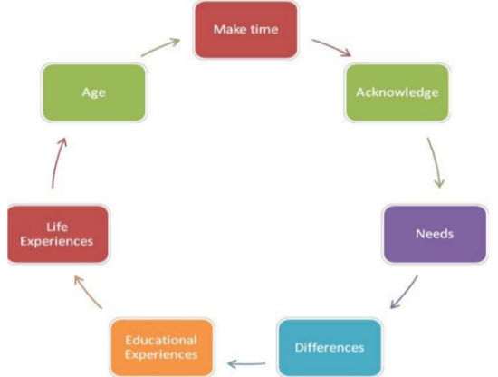**Mandela Model (Tedam 2012**) - A tool created by Dr Prospera Tedam following research she undertook, which looked at the experiences of black African students studying social work in the UK. The model was developed to support practice educators to engage more effectively with black African students, however it is a model that can be used to explore similarities and differences between any practice educator and student.

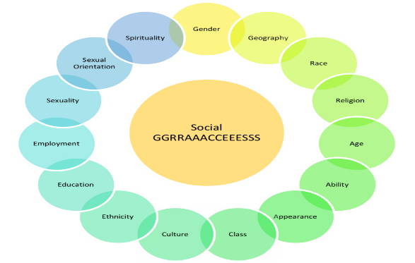**Social Graces (Burnam 2013)** - The acronym 'social graces' is used to represent aspects of difference in beliefs, power, and lifestyle, visible and invisible, voiced, and unvoiced, to which we might pay attention to in our practice and supervision. The list of 'social graces' has developed and currently represents many areas of personal and social identity, though the acronym can be more than a list.

|  |  |
| --- | --- |
| **5.** | **Local Information** |

Social work students often find it useful to have information about local services and organisations. Making enquiries and finding out such information will form part of your on-going development during placement.

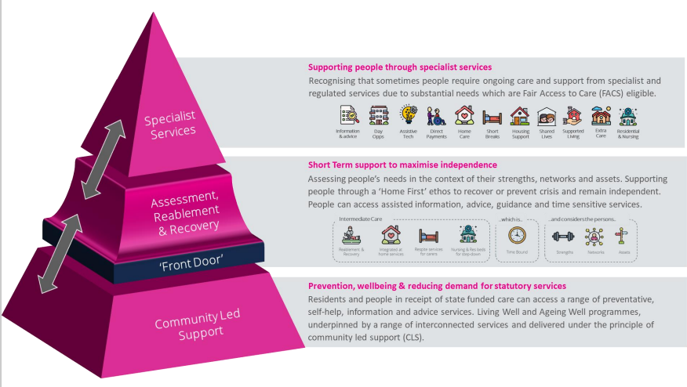The statutory guidance for the Care Act 2014 embeds strengths-based working as a requirement when it directs us to: consider the person’s own strengths or if any other support might be available in the community to meet the outcomes they want to achieve. We have a responsibility to identify ways to reduce, delay, or prevent their need for future care and support, and improve wellbeing. This could be using assistive technology, equipment, signposting and providing information and advice about local voluntary services and community led support. Salford Adult Social Care (ASC) promotes Strength Based Working and Community Led Support (CLS) working to design and deliver different ways of working which maximise the strengths and community connections of people locally which you can find more about here <https://www.ndti.org.uk/change-and-development/community-led-support>

Salford is truly rich and fortunate to have several community and voluntary services in the local area. Your team will be able to share details about local services and a few websites for your perusal have been included below:

**My City Directory** the Salford Directory is where you can find information about what is going on in Salford and details on how to access services, organisations, and activities [mycity Directory (salford.gov.uk)](https://directory.salford.gov.uk/kb5/salford/directory/home.page)

**Salford CVS (Community and Voluntary Services)**is the city-wide infrastructure organisation for the Voluntary, Community and Social Enterprise (VCSE) sector; providing specialist information, advice, development support and opportunities for influence and collaboration. [Home | Salford CVS](https://www.salfordcvs.co.uk/)

**Healthwatch Salford** - Healthwatch Salford is a health and social care champion. As an independent statutory body, this organisation has the power to make sure NHS leaders and other decision makers listen to feedback and improve standards of care. They help people to have their say and get the information and advice needed. [Home | Healthwatch Salford](https://www.healthwatchsalford.co.uk/)

**Gaddum…Advice and support for carers in** **Salford** - This service supports carers through one-to-one and group support sessions, benefits advice, carers assessments and further intervention if needed (such as advocacy) [Gaddum - Gaddum](https://www.gaddum.org.uk/)

**Mind in Salford** - Mind in Salford is an independent, user focused charity providing vital services to make a positive difference to the wellbeing and mental health of local people. [Home - Mind In Salford Mind In Salford](https://www.mindinsalford.org.uk/) . At the Advocacy Hub, Mind in Salford provide both statutory and non-statutory advocacy. [Advocacy - Mind In Salford Mind In Salford](https://www.mindinsalford.org.uk/advocacy-home-2/)

**Health Improvement Service (HIS)** provide one to one tailored support, and group-based activities within your local community to help you improve your health and wellbeing. [Health Improvement Connect•Salford City Council](https://www.salford.gov.uk/health-and-social-care/health-services/health-improvement-connect/)

**Salford Age UK** -Age UK Salford is an independent local charity and has been working actively in the local community for over 40 years.

Age UK Salford full list of services available: Age UK Salford | Our Services

A directory of useful numbers can be found through our staff Sharepoint which you can add as a web favourite for quick access and other key updates [SCO_Adult Social Care - Useful Telephone Numbers](https://greatermanchester.sharepoint.com/sites/SCO_AdultSocialCareImprovementProgramme2/Lists/Useful%20Telephone%20Numbers/AllItems.aspx?as=json)

|  |  |
| --- | --- |
| **6.** | **Social Work England** |

**Social Work England Professional Standards (SWEPS)**

The SWEPS are a set of key statements all Social Workers in England must know, understand and be able to do.

1. Promote the rights, strengths and wellbeing of people, families, and communities.
2. Establish and maintain the trust and confidence of people.
3. Be accountable for the quality of my practice and the decisions I make.
4. Maintain my continuing professional development.
5. Act safely, respectfully and with professional integrity.
6. Promote ethical practice and report concerns.

<https://www.socialworkengland.org.uk/standards/professional-standards/>

We would encourage you to become familiar with these key standards and consider how you can achieve and maintain these during placement. You will be guided by your Practice Educator, team, supervisor, and the organisation as whole, including access to key policies and guidelines to strengthen your understanding of the SWEPS both in and outside of a work setting.

**A message from Social Work England to social work students:** Social work courses aim to ensure that students develop the skills and knowledge necessary to meet the professional standards by the time they complete the course. Although we do not regulate students, we do expect them to understand and work towards our professional standards in preparation for when they apply for registration. Students should make sure that during their course, including while they are on placement, they do not do anything that contravenes the professional standards or the policies and procedures of their course or placement provider (extract from: [Students and graduates - Social Work England](https://www.socialworkengland.org.uk/education-training/students-and-graduates/))

**Social Work England guidelines on Practice Placements:** This guidance supplements the social work qualifying education and training standards (2021). The requirements around placements are addressed under standard 2 of the qualifying education and training standards, which is about the learning environment:

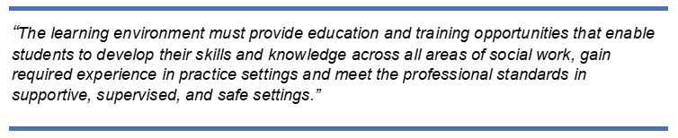

We are committed to upholding the SWE requirements on placement providers, for all the students based with us and more can be found via this link; <https://www.socialworkengland.org.uk/standards/practice-placements-guidance/>

|  |  |
| --- | --- |
| **7.** | **Professional Capabilities Framework** |

During your placement you will have access to an array of learning opportunities which will help you to achieve and enrich your understanding, knowledge, and skills of the nine areas in the Professional Capabilities Framework (PCF).

The PCF is the overarching framework for social work in England, from pre-qualifying to strategic levels, across all practice areas. It is a generic, profession-owned framework for all social work that provides guidance and a common understanding of what it means to be a social worker at all stages of a career – from starting a qualifying course through to senior, advanced, and strategic roles.

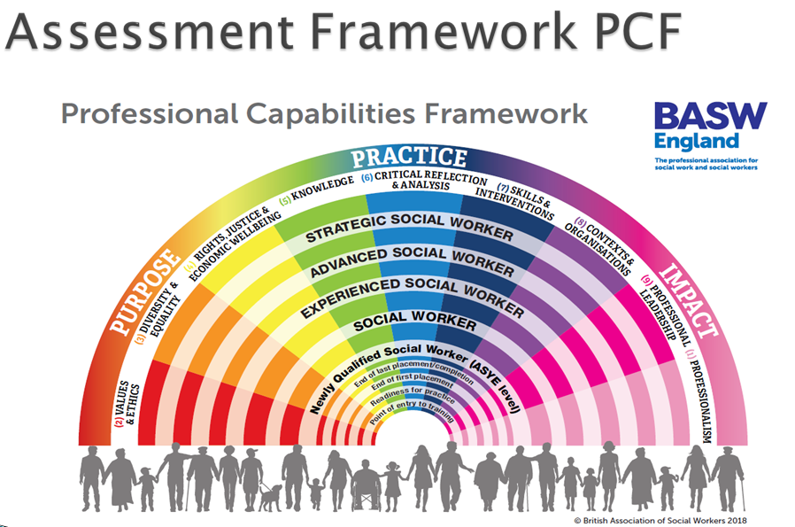

The framework was developed over several years (from 2010) by social workers and social work leaders. It is now formally hosted on behalf of the sector by BASW who, following extensive consultation, updated the PCF in 2018. The PCF is a framework that promotes and supports ongoing learning and continuing professional development (CPD) in any specialism. The PCF guides the development of social workers’ capabilities and confidence in managing risk, ambiguity, and complexity at nine levels of practice across all specialisms.

The PCF has nine domains (or areas) within it. For each one, there is a main statement and an elaboration. Then at each level within the PCF, detailed capabilities have been developed explaining how social workers should expect to evidence that area in practice. The nine capabilities should be seen as interdependent, not separate. As they interact in professional practice, so there are overlaps between the capabilities within the domains, and many issues will be relevant to more than one domain. Understanding of what a social worker does will only be complete by considering all nine capabilities.

Following a consultation by BASW the PCF was refreshed in 2018. This introduced three “Super Domains “– Purpose, Practice, and Impact - under which are grouped the three most relevant PCF domains. However, they cut across them all.

**Purpose:** Why we do what we do as social workers, our values, and ethics, and how we approach our work

**Practice:** What we do – the specific skills, knowledge, interventions, and critical analytic abilities we develop to act and do social work

**Impact:** How we make a difference and how we know we make a difference. Our ability to bring about change through our practice, through our leadership, through understanding our context and through our overall professionalism.

You can find further information about the PCF in the links below:

PCF descriptors for last placement

<https://basw.co.uk/training-cpd/professional-capabilities-framework/end-last-placementcompletion>

Guidance on using the 2018 refreshed PCF

<https://basw.co.uk/sites/default/files/pcf-refresh-2018.pdf>

Mapping the PCF, KSS and Regulatory Standards in England

<https://basw.co.uk/sites/default/files/resources/mapping-the-pcf-kss-and-regulatory-standards-in-england.pdf>

|  |  |
| --- | --- |
| **8.** | **Training and Development Opportunities** |

**ASC Learning and Development Team**

The ASC learning and development team is a group of professionals who are committed to enhancing the knowledge, skills, and expertise of the adult social care workforce in Salford. The team strives to invest in the continued professional development of staff and students to ensure that they feel professionally confident and equipped to deliver person-centred, compassionate and outcomes focused care to our communities. You will receive regular comms regarding training and development opportunities from this team during your time on placement via [ASCLearningandDevelopment@nca.nhs.uk](mailto:ASCLearningandDevelopment@nca.nhs.uk)

**Corporate Welcome**

Your practice educator will book you onto the corporate welcome day by emailing [Roz.Lawson@nca.nhs.uk](mailto:Roz.Lawson@nca.nhs.uk). The corporate welcome is aimed at employed staff; however, students can attend to gain an understanding of context and organisation. You will complete the local induction that is arranged by your practice educator.

**Mandatory Training**

Once you have an email address, please contact [ASCLearningandDevelopment@nca.nhs.uk](mailto:ASCLearningandDevelopment@nca.nhs.uk) to complete an External Learner Request Form so you can be signed up to ESR to access NCA Training.

Once on ESR, students must complete the below mandatory training to ensure all statutory obligations as well as national and best practice standards are met.

|  |  |
| --- | --- |
| **Title** | **Format** |
| Conflict Resolution | eLearning |
| Corporate Welcome | Face to Face |
| Equality, Diversity and Human Rights | eLearning |
| Fire Safety | Face to Face |
| Fraud Awareness | eLearning |
| Health Safety and Welfare | eLearning |
| Infection Prevention and Control | eLearning |
| Information Governance | eLearning |
| Local Induction | Face to Face |
| Moving and Handling | eLearning |
| Oliver McGowan Learning Disability and Autism | eLearning |
| Prevent Level 3 | eLearning |
| Resuscitation Adults Level 1 | eLearning |
| Safeguarding Adults Level 1, 2 and 3 | eLearning |
| Safeguarding Children Level 1, 2 and 3 | eLearning |

**Job Essential Training and the Safeguarding Adults Board**

The ASC learning and development team and the Salford Safeguarding Adults Board (SSAB) regularly arrange safeguarding training and development opportunities. There is also close partnership working between Salford Adults and Children’s services. Our staff attend training that is hosted by the Salford Safeguarding Children’s Partnership (SSCP) to promote shared understanding, interagency working, and whole family approaches. You will regularly receive information about safeguarding training opportunities, and you will need to seek approval from your Practice Educator to attend. You can explore more about the SSAB and SSCP through the following websites;

[Salford Safeguarding Adults Board](https://safeguardingadults.salford.gov.uk/)

[Home | Salford Safeguarding Children Partnership](https://safeguardingchildren.salford.gov.uk/)

**Social Work Student Support Groups**

You will be invited to monthly support groups that are arranged by the social work development lead, Shoyley Chowdhury. These groups will focus on topics relevant to your course and practice learning. You will meet other social work students where you can share ideas and access peer support to maintain wellbeing. Here are a couple of pictures from our previous groups, it would be great if you could join us.

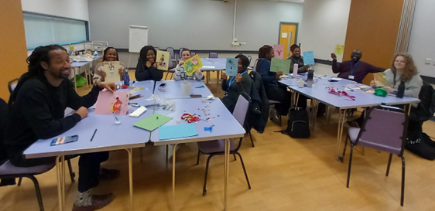

**Student Masterclasses**

The key partners of the Greater Manchester Social Work Academy (GMSWA) provide a series of masterclasses for social work students, which are short bespoke online sessions available to all social work students in Greater Manchester. The GMSWA Student Hub also contains links to additional training and resources that will support you in the preparation and completion of placement [Student Hub – GMSWA](https://gmswa.co.uk/student-hub/)

**Research in Practice**

In Salford, we have access to Research in Practice which includes a range of learning and development resources to help us make evidence-informed decisions in our day-to-day practice. The resources, which are relevant to people in all roles, provide opportunities for flexible and accessible learning and are structured around [topics](https://eur02.safelinks.protection.outlook.com/?url=https%3A%2F%2Fwww.researchinpractice.org.uk%2Fall%2Ftopics%2F&data=05%7C01%7C%7Cf8447a9c77c44699cd8c08dba21cb3cc%7C9a12677ec2e94deba58aee1c59ac0161%7C0%7C0%7C638282016512760921%7CUnknown%7CTWFpbGZsb3d8eyJWIjoiMC4wLjAwMDAiLCJQIjoiV2luMzIiLCJBTiI6Ik1haWwiLCJXVCI6Mn0%3D%7C3000%7C%7C%7C&sdata=RlsQwg6JTInRnr84WKI0p%2B4%2F%2FJ57dq%2F9ZvYHg8qqAAs%3D&reserved=0) such as [assessment](https://eur02.safelinks.protection.outlook.com/?url=https%3A%2F%2Fwww.researchinpractice.org.uk%2Fall%2Ftopics%2Fassessment%2F&data=05%7C01%7C%7Cf8447a9c77c44699cd8c08dba21cb3cc%7C9a12677ec2e94deba58aee1c59ac0161%7C0%7C0%7C638282016512760921%7CUnknown%7CTWFpbGZsb3d8eyJWIjoiMC4wLjAwMDAiLCJQIjoiV2luMzIiLCJBTiI6Ik1haWwiLCJXVCI6Mn0%3D%7C3000%7C%7C%7C&sdata=WtVNVeIeZBwpHd6WkcZvAAtFcwOnCDg3RtaXkq2PH4Q%3D&reserved=0), [integrated working](https://eur02.safelinks.protection.outlook.com/?url=https%3A%2F%2Fwww.researchinpractice.org.uk%2Fadults%2Ftopics%2Fintegrated-working%2F&data=05%7C01%7C%7Cf8447a9c77c44699cd8c08dba21cb3cc%7C9a12677ec2e94deba58aee1c59ac0161%7C0%7C0%7C638282016512760921%7CUnknown%7CTWFpbGZsb3d8eyJWIjoiMC4wLjAwMDAiLCJQIjoiV2luMzIiLCJBTiI6Ik1haWwiLCJXVCI6Mn0%3D%7C3000%7C%7C%7C&sdata=pvwrVajgcp7a2J6pcndJgntJeCVkdOpR3oeoZVOWy7g%3D&reserved=0), [resilience](https://eur02.safelinks.protection.outlook.com/?url=https%3A%2F%2Fwww.researchinpractice.org.uk%2Fall%2Ftopics%2Fresilience%2F&data=05%7C01%7C%7Cf8447a9c77c44699cd8c08dba21cb3cc%7C9a12677ec2e94deba58aee1c59ac0161%7C0%7C0%7C638282016512760921%7CUnknown%7CTWFpbGZsb3d8eyJWIjoiMC4wLjAwMDAiLCJQIjoiV2luMzIiLCJBTiI6Ik1haWwiLCJXVCI6Mn0%3D%7C3000%7C%7C%7C&sdata=lnhIfBkTNRzu9EVS84HfzV2eaL9tIOUoIVsAm6TtEWQ%3D&reserved=0), [safeguarding](https://eur02.safelinks.protection.outlook.com/?url=https%3A%2F%2Fwww.researchinpractice.org.uk%2Fall%2Ftopics%2Fsafeguarding%2F&data=05%7C01%7C%7Cf8447a9c77c44699cd8c08dba21cb3cc%7C9a12677ec2e94deba58aee1c59ac0161%7C0%7C0%7C638282016512760921%7CUnknown%7CTWFpbGZsb3d8eyJWIjoiMC4wLjAwMDAiLCJQIjoiV2luMzIiLCJBTiI6Ik1haWwiLCJXVCI6Mn0%3D%7C3000%7C%7C%7C&sdata=5REG9rD9juoqpfEV5%2B1EcdMxIexRba%2FaF2lRKV4S0iw%3D&reserved=0), [strengths-based working](https://eur02.safelinks.protection.outlook.com/?url=https%3A%2F%2Fwww.researchinpractice.org.uk%2Fall%2Ftopics%2Fstrengths-based-working%2F&data=05%7C01%7C%7Cf8447a9c77c44699cd8c08dba21cb3cc%7C9a12677ec2e94deba58aee1c59ac0161%7C0%7C0%7C638282016512760921%7CUnknown%7CTWFpbGZsb3d8eyJWIjoiMC4wLjAwMDAiLCJQIjoiV2luMzIiLCJBTiI6Ik1haWwiLCJXVCI6Mn0%3D%7C3000%7C%7C%7C&sdata=pw9ENI2tPsn6b%2BjlWesXiiO7ViySlbvTKdvHXSKwhKA%3D&reserved=0) and more. You can access learning in a variety of formats as described below.

Included free to you as part of our membership is the following:

* A wide range of [publications](https://eur02.safelinks.protection.outlook.com/?url=https%3A%2F%2Fwww.researchinpractice.org.uk%2Fall%2Fpublications%2F&data=05%7C01%7C%7Cf8447a9c77c44699cd8c08dba21cb3cc%7C9a12677ec2e94deba58aee1c59ac0161%7C0%7C0%7C638282016512760921%7CUnknown%7CTWFpbGZsb3d8eyJWIjoiMC4wLjAwMDAiLCJQIjoiV2luMzIiLCJBTiI6Ik1haWwiLCJXVCI6Mn0%3D%7C3000%7C%7C%7C&sdata=NYqaQu3KmtwPUH6v8jMl5s6Padyrb3ggYvOLmnZv87Y%3D&reserved=0) addressing different [topics and priorities](https://eur02.safelinks.protection.outlook.com/?url=https%3A%2F%2Fwww.researchinpractice.org.uk%2Fall%2Ftopics%2F&data=05%7C01%7C%7Cf8447a9c77c44699cd8c08dba21cb3cc%7C9a12677ec2e94deba58aee1c59ac0161%7C0%7C0%7C638282016512760921%7CUnknown%7CTWFpbGZsb3d8eyJWIjoiMC4wLjAwMDAiLCJQIjoiV2luMzIiLCJBTiI6Ik1haWwiLCJXVCI6Mn0%3D%7C3000%7C%7C%7C&sdata=RlsQwg6JTInRnr84WKI0p%2B4%2F%2FJ57dq%2F9ZvYHg8qqAAs%3D&reserved=0) throughout the sector, free to access and download.
* A regular programme of [workshops and conferences](https://eur02.safelinks.protection.outlook.com/?url=https%3A%2F%2Fwww.researchinpractice.org.uk%2Fall%2Fevents-training%2F&data=05%7C01%7C%7Cf8447a9c77c44699cd8c08dba21cb3cc%7C9a12677ec2e94deba58aee1c59ac0161%7C0%7C0%7C638282016512760921%7CUnknown%7CTWFpbGZsb3d8eyJWIjoiMC4wLjAwMDAiLCJQIjoiV2luMzIiLCJBTiI6Ik1haWwiLCJXVCI6Mn0%3D%7C3000%7C%7C%7C&sdata=CpmOIojRuhh9l1fICDZH9AAHH2SFHOcYtqFHUh8XHw4%3D&reserved=0) at venues across the country.
* [Live](https://eur02.safelinks.protection.outlook.com/?url=https%3A%2F%2Fwww.researchinpractice.org.uk%2Fall%2Fevents-training%2F&data=05%7C01%7C%7Cf8447a9c77c44699cd8c08dba21cb3cc%7C9a12677ec2e94deba58aee1c59ac0161%7C0%7C0%7C638282016512760921%7CUnknown%7CTWFpbGZsb3d8eyJWIjoiMC4wLjAwMDAiLCJQIjoiV2luMzIiLCJBTiI6Ik1haWwiLCJXVCI6Mn0%3D%7C3000%7C%7C%7C&sdata=CpmOIojRuhh9l1fICDZH9AAHH2SFHOcYtqFHUh8XHw4%3D&reserved=0) and [recorded webinars](https://eur02.safelinks.protection.outlook.com/?url=https%3A%2F%2Fwww.researchinpractice.org.uk%2Fall%2Fcontent-pages%2Frecorded-webinars%2F&data=05%7C01%7C%7Cf8447a9c77c44699cd8c08dba21cb3cc%7C9a12677ec2e94deba58aee1c59ac0161%7C0%7C0%7C638282016512760921%7CUnknown%7CTWFpbGZsb3d8eyJWIjoiMC4wLjAwMDAiLCJQIjoiV2luMzIiLCJBTiI6Ik1haWwiLCJXVCI6Mn0%3D%7C3000%7C%7C%7C&sdata=%2BSl2V8zf5AAGOG%2FlrUKdcIru%2BNIwjyHLkz25l%2BsAFKQ%3D&reserved=0): one-hour online presentations on a wide range of topics.
* Monthly [topic led live sessions](https://eur02.safelinks.protection.outlook.com/?url=https%3A%2F%2Fwww.researchinpractice.org.uk%2Fall%2Fevents-training%2F&data=05%7C01%7C%7Cf8447a9c77c44699cd8c08dba21cb3cc%7C9a12677ec2e94deba58aee1c59ac0161%7C0%7C0%7C638282016512760921%7CUnknown%7CTWFpbGZsb3d8eyJWIjoiMC4wLjAwMDAiLCJQIjoiV2luMzIiLCJBTiI6Ik1haWwiLCJXVCI6Mn0%3D%7C3000%7C%7C%7C&sdata=CpmOIojRuhh9l1fICDZH9AAHH2SFHOcYtqFHUh8XHw4%3D&reserved=0) providing opportunities to hear key research messages about core topics, reflect with peers and find out about further resources available to support your practice.
* [Policy Updates](https://eur02.safelinks.protection.outlook.com/?url=https%3A%2F%2Fwww.researchinpractice.org.uk%2Fall%2Fcontent-pages%2Fpolicy-updates%2F&data=05%7C01%7C%7Cf8447a9c77c44699cd8c08dba21cb3cc%7C9a12677ec2e94deba58aee1c59ac0161%7C0%7C0%7C638282016512760921%7CUnknown%7CTWFpbGZsb3d8eyJWIjoiMC4wLjAwMDAiLCJQIjoiV2luMzIiLCJBTiI6Ik1haWwiLCJXVCI6Mn0%3D%7C3000%7C%7C%7C&sdata=WW1iD8H42whZvi%2F%2FnemqriBzap0%2FSR35obEZYe8XAII%3D&reserved=0): monthly rounds ups to keep you up to date with important policy, government reports, consultations, news and more
* [Case Law and Legal Summaries](https://eur02.safelinks.protection.outlook.com/?url=https%3A%2F%2Fwww.researchinpractice.org.uk%2Fall%2Fcase-law-and-legal-summaries%2F&data=05%7C01%7C%7Cf8447a9c77c44699cd8c08dba21cb3cc%7C9a12677ec2e94deba58aee1c59ac0161%7C0%7C0%7C638282016512917571%7CUnknown%7CTWFpbGZsb3d8eyJWIjoiMC4wLjAwMDAiLCJQIjoiV2luMzIiLCJBTiI6Ik1haWwiLCJXVCI6Mn0%3D%7C3000%7C%7C%7C&sdata=b52mha8Epcz8jFKffc5hwfq7gn1jrToM94qy7DpmhPk%3D&reserved=0): overview and analysis of selected cases each month, highlighting implications for practice.
* [Podcasts](https://eur02.safelinks.protection.outlook.com/?url=https%3A%2F%2Fwww.researchinpractice.org.uk%2Fall%2Fcontent-pages%2Fpodcasts%2F&data=05%7C01%7C%7Cf8447a9c77c44699cd8c08dba21cb3cc%7C9a12677ec2e94deba58aee1c59ac0161%7C0%7C0%7C638282016512917571%7CUnknown%7CTWFpbGZsb3d8eyJWIjoiMC4wLjAwMDAiLCJQIjoiV2luMzIiLCJBTiI6Ik1haWwiLCJXVCI6Mn0%3D%7C3000%7C%7C%7C&sdata=mmkzBTaH8cgHOyI3nvEGBuhQDesRWfAV8jYP0RLYyH0%3D&reserved=0): a range of short and longer listens on various topics of interest.
* [News and views](https://eur02.safelinks.protection.outlook.com/?url=https%3A%2F%2Fwww.researchinpractice.org.uk%2Fall%2Fnews-views%2F&data=05%7C01%7C%7Cf8447a9c77c44699cd8c08dba21cb3cc%7C9a12677ec2e94deba58aee1c59ac0161%7C0%7C0%7C638282016512917571%7CUnknown%7CTWFpbGZsb3d8eyJWIjoiMC4wLjAwMDAiLCJQIjoiV2luMzIiLCJBTiI6Ik1haWwiLCJXVCI6Mn0%3D%7C3000%7C%7C%7C&sdata=BuWROUlY5XfQ35I6cJeQdioJO6sNwoCExQmkeP%2FoMOU%3D&reserved=0): blogs, discussion and analysis of the latest news, information, and research – written by and for professionals.

To access all the above and more, simply [set up an account](https://eur02.safelinks.protection.outlook.com/?url=https%3A%2F%2Fwww.researchinpractice.org.uk%2Fregister%2F&data=05%7C01%7C%7Cf8447a9c77c44699cd8c08dba21cb3cc%7C9a12677ec2e94deba58aee1c59ac0161%7C0%7C0%7C638282016512917571%7CUnknown%7CTWFpbGZsb3d8eyJWIjoiMC4wLjAwMDAiLCJQIjoiV2luMzIiLCJBTiI6Ik1haWwiLCJXVCI6Mn0%3D%7C3000%7C%7C%7C&sdata=6buiAlPosagj2drjJzQstRp%2BjCCuVIftLKA9gPB5k%2B0%3D&reserved=0). Please note you should use your work email address and will receive a validation email at this address, after that you can log into and access the resources from any laptop, tablet, phone, or other device with internet access.

**Recording Training**

It is good practice to keep a record of all the training and development opportunities you access, and to reflect on how these have enriched your understanding and the impact it will have upon others. Keeping a record of training can also be used for evidence in your portfolio and for future job applications.

**Library Services**

All students in the Northern Care Alliance (NCA) can register with the Library and Knowledge Services, to access books, e-books, and journal articles. To register, please follow the link below to create an account.

[Join the Library :: Northern Care Alliance](https://eur02.safelinks.protection.outlook.com/?url=https%3A%2F%2Fwww.northerncarealliance.nhs.uk%2Fresearch-education%2Flibrary-service%2Fjoin-library&data=05%7C01%7C%7Cdaa1999f5f714ed894a308db2eacb5c6%7C9a12677ec2e94deba58aee1c59ac0161%7C0%7C0%7C638155091528357602%7CUnknown%7CTWFpbGZsb3d8eyJWIjoiMC4wLjAwMDAiLCJQIjoiV2luMzIiLCJBTiI6Ik1haWwiLCJXVCI6Mn0%3D%7C3000%7C%7C%7C&sdata=KDMdHv6FeGwlMFtLhU%2FLwaPFbbuUjvXO38wedAjpoaM%3D&reserved=0)

And there is further information available on:

[Library and Knowledge Service :: Northern Care Alliance](https://eur02.safelinks.protection.outlook.com/?url=https%3A%2F%2Fwww.northerncarealliance.nhs.uk%2Fresearch-education%2Flibrary&data=05%7C01%7C%7Cdaa1999f5f714ed894a308db2eacb5c6%7C9a12677ec2e94deba58aee1c59ac0161%7C0%7C0%7C638155091528357602%7CUnknown%7CTWFpbGZsb3d8eyJWIjoiMC4wLjAwMDAiLCJQIjoiV2luMzIiLCJBTiI6Ik1haWwiLCJXVCI6Mn0%3D%7C3000%7C%7C%7C&sdata=3YsQZ1%2Fod3yV%2BLa%2FevUS3HmWheJyu%2BKbGZoq4JnQjxM%3D&reserved=0)

For students based in Greater Manchester Mental Health (GMMH) teams, the link to access library services is:

[Library and Knowledge Services | Greater Manchester Mental Health NHS FT (gmmh.nhs.uk)](https://www.gmmh.nhs.uk/services-library/)

|  |  |
| --- | --- |
| **9.** | **Policies, Procedures and Practice Guidance** |

**The Salford Adult Social Care (ASC) Information Hub**

The Salford ASC information hub is a website that is available to the public and professionals for information on our services. There are professionals only areas which are password protected and contain our social work policies, practice guides and standard operating procedures. As a student you can register and set up an account using your work email via the following link: [Professionals Area – Salford Adult Social Care Information Hub (salfordappp.co.uk)](https://eur02.safelinks.protection.outlook.com/?url=https%3A%2F%2Fwww.salfordappp.co.uk%2Fappp-professionals%2F&data=05%7C02%7CShoyley.Chowdhury%40nca.nhs.uk%7C29f6a077ce154b7c26a008dc1864b852%7C9a12677ec2e94deba58aee1c59ac0161%7C0%7C0%7C638412068060207647%7CUnknown%7CTWFpbGZsb3d8eyJWIjoiMC4wLjAwMDAiLCJQIjoiV2luMzIiLCJBTiI6Ik1haWwiLCJXVCI6Mn0%3D%7C3000%7C%7C%7C&sdata=p13H133wfGDDybvyPNaFyWp9JuQGpC5YZNMreBw0kkU%3D&reserved=0) (by scrolling to the bottom of the webpage and filling in the mandatory fields). Having an archive of policies, procedures and guides help us work in a more consistent and strengths-based way. Below are ‘**terms of reference**’ used to explain the differences between each concept:

|  |  |
| --- | --- |
| **Terms of reference** | |
| **Policy** | Statement of intent and the basis for making decisions influenced by the legal framework |
| **Procedure** | How to implement the policy, what we do locally |
| **Guidance** | Additional supporting information that can help to follow the procedure |

**Northern Care Alliance (NCA) Policy Hub**

Our adult social care specific policies and procedures are stored in our ASC information hub and the generic organisational policies (for all staff in the trust) are contained in the NCA policy hub <https://www.northerncarealliance.nhs.uk/our-policy-hub>. The NCA policy hub holds key documents related to:

* Confidentiality
* Information Governance
* Lone Working
* Raising Concerns - Whistleblowing
* Safeguarding Children and Adults (along with those available through SSAB - [Professionals | Salford Safeguarding Adults Board](https://safeguardingadults.salford.gov.uk/professionals/))

All students are expected to adhere to key organisational policies and procedures. You will be provided time in your induction to read through relevant documents and familiarise yourself with key platforms to obtain policies, procedures, and guidance.

**Salford Safeguarding Adult Boards (SSAB)**

Salford’s safeguarding adults’ policies and procedures are all stored on the Salford Safeguarding Adults Board website: <https://safeguardingadults.salford.gov.uk/>

|  |  |
| --- | --- |
| 1. **Supervision** |  |

All students will receive regular formal and informal supervision during placement. As advised by Social Work England, in the guidance of practice placements (<https://www.socialworkengland.org.uk/standards/practice-placements-guidance/#supervision>):

*“Students must be supervised appropriately during their placement to ensure the safety of people with lived experience of social work and their own safety. Appropriate social work supervision is also key to ensuring that students get a good learning experience and can access appropriate learning opportunities. The learning and development of each student on placement is overseen by a named Practice Educator, who is a registered social worker.”*

In some instances, students may have an Off-Site Practice Educator (OSPE), and an On-Site Supervisor (OSS), who will work in tandem to provide regular supervision. The OSS would provide task and work-based supervision, whereas the Practice Educator will focus more on theory to practice, critical reflection, learning needs and professional development. All supervision arrangements will be recorded within the initial learning agreement meeting.

**What do we mean by supervision?**

Some would describe supervision as a professional conversation that should support our ability to provide consistent and emotionally regulated interventions.

It should:

* Consider well-being, self-care, and practical arrangements.
* Enable effective line management and organisational accountability through reflective discussion.
* Identify and address issues related to caseloads and work management.
* Help to identify and achieve personal learning and development.
* Help us to understand the ‘bigger picture’ and gain a holistic understanding.
* Offer opportunities for critically reflective discussion and analysis.
* Improve the quality of support and interventions with in thereby individuals and carers, improving their outcomes.

Supervision is a two-way process between the supervisor and supervisee. One way of facilitating good supervision is to draw up a Supervision Agreement as it is important to have a transparent framework for supervision so that the purpose is clear, and everyone benefits from the process. All placement supervisors and students will need to sign an initial supervision agreement that specifies roles, responsibilities, and practical arrangements for supervision. Students and supervisors can use a supervision template as a guide for key agenda points for discussion. Please see **Appendix 3** for copies of a supervision agreement and supervision template that can be used; your Practice Educator may suggest using alternate templates.

There are many resources which can help you understand the purposes and functions of social work supervision, including those that can be located on Research in Practice [Learning resources & events on supervision | Research in Practice](https://www.researchinpractice.org.uk/all/topics/supervision/).

Other resources that you may find helpful to make good use of supervision include

* Youtube video Siobhan Maclean Student Connects [MAKING THE MOST OF SUPERVISION The what? why? and how?](https://www.youtube.com/watch?v=mKNVaqAOn8I&list=PL-VvBcDnqAcUTAUXherZgybLfb0QB567l&index=22)
* Social Work England CPD requirements [Supervision - Social Work England](https://www.socialworkengland.org.uk/cpd/supervision/)
* Research in Practice - Morrison’s 4x4x4 model of supervision [The 4x4x4 supervision model | Research in Practice](https://www.researchinpractice.org.uk/all/content-pages/videos/the-4x4x4-supervision-model/)

|  |  |
| --- | --- |
| **11.** | **Reflective Practice** |

**What do we mean by reflection?**

In social work, we often use different ways to develop our understanding of reflection to become more reflective as practitioners. Overall, there is consensus that reflection is an essential aspect of social work, as it helps practitioners to learn, grow and develop in and through practice.

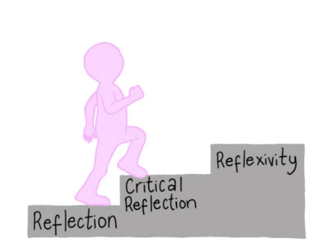

The term reflective practice tends to be used to cover concepts such as ‘*reflection*’, ‘*critical reflection*’, and ‘*reflexivity*’, however there are key differences between all three terms. All social work students are on a journey to develop and refine their skills and ability to change from ‘*reflective*’ in practice to becoming more ‘*reflexive*’. A brief outline of each key concept has been offered below:

**Reflection** –

* Thinking actively and persistently.
* Exploration of thoughts, insight, feelings, and learning.
* Actively reflecting in the moment, not just in hindsight.
* A reflection in a mirror in an exact replica of what is in front, but in professional practice what might be improvements of the original.
* The mental process of trying to structure and restructure an experience, or problem or existing knowledge or insight.
* Process of reviewing an experience of practice to describe, analyse, evaluate, and so inform learning about practice.

**Critical Reflection** –

* Important difference (from reflection) is that critical reflection places emphasis on understanding power relations, including ways to reduce power dynamics and promote empowerment and emancipatory practice.
* A window through which the practitioner can view and focus self, understanding own lived experiences, beliefs, and values, to confront and resolve any contradictions and bias.
* To uncover hidden assumptions and build self-awareness.
* Add issues of socio-political context and challenges.
* Learning from an experience, making new meaning and interpretations, considering evidence, other perspectives, and contexts.
* Sufficient depth to create transformative change.
* Often the concept is confused with ‘self-criticism’, however is not solely focused on what didn’t go well.
* Further detailed in Domain 6 of Professional Capabilities Framework (PCF)

**Reflexivity**

* A concept which originates from social sciences research and holds applicability to reflective practice in social work.
* A form of self-reflection, or other reflection to make sense of social circumstances and social life, using this in a circulatory manner.
* A process of looking inwards and outwards.
* Adds issues of relationships, including inter-connections that are not always apparent. There is centrality of self.
* Further broken down to three forms of reflexivity
  + Personal reflexivity - exploring the way our beliefs, experiences, interests, to shape practice and approach.
  + Relational reflexivity – being reflexive about relationships and how they are constructed.
  + Epistemological reflexivity - considers aspects such as design, the research method and how different approaches work differently.
* An awareness of thinking, bias, or blind spots, which influence the way you interpret people and situations, in turn practice.

This YouTube video by social work educator Siobhan Maclean helps to explain key differences between the three concepts and might be useful to watch, particularly at the beginning of placement <https://www.youtube.com/watch?v=6UxggX6M1eg> . Furthermore, the Post-qualifying standards for social work practice supervisors in adult social care, offer some helpful definitions of ‘Critical Reflection’ and ‘Reflexivity’ <https://assets.publishing.service.gov.uk/government/uploads/system/uploads/attachment_data/file/762818/Post-qualifying_standards_for_social_work_supervisors.pdf>

There are many methods and techniques to aid reflective practice, including:

* Using supervision (both formal and informal, with supervisor or peers).
* A ‘critical friend’ to discuss practice experiences and being open to challenge.
* Mind mapping ideas and thoughts.
* Reflective written pieces.
* Using reflective practice models.
* Maintaining a reflective journal (reflective logs).
* Considering theory to practice

Further information about the latter three points on **Reflective Practice Models**, **Reflective Journals**, and **Theory to Practice,** have been detailed next.

**Reflective Practice Models**

Using reflective models can help to promote reflective practice. Reflective models contain interesting prompts and questions, designed to make sense of a learning experience to develop a deeper understanding, to in turn promote positive changes in practice.

There is a wide range of reflective models and paradigms, to suit different learning styles and promote critical thinking. We often use reflective models from other disciplines such as Psychology, but there are some reflective practice models which derive from Social Work.

It is generally agreed that there are two types of reflective models, **process models** (for example Gibbs Cycle) which moves through a linear process; and **component models** (for example Korthagen’s onion) that can be used in any order and generally uses symbols as prompts for reflection, particularly to consider power relations.

It is important to explore and try out different models to find out what works best for you. Each team will have access to a set of Reflective Practice theory cards that can be used as a visual and tactile way to promote learning and reflective discussions.

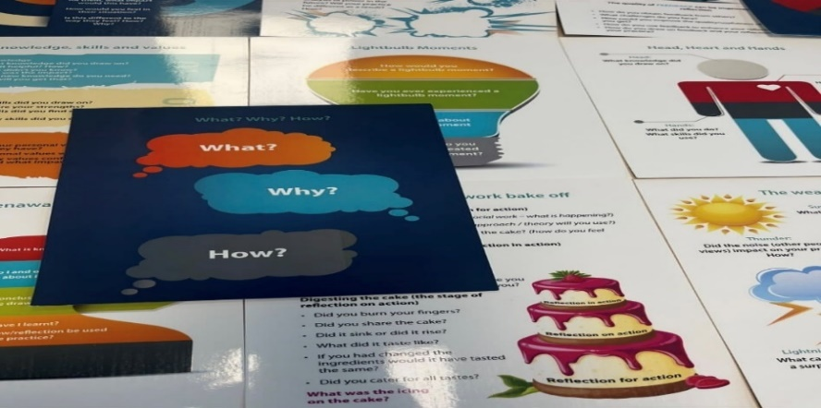

**Reflective Log**

Each placement day has 30 minutes of reflective time and students will use this time to complete their logs. These logs should be shared with the Practice Educator in supervision and in between times if necessary. Reflective logs are used to capture significant learning experiences. Some may consider this as a form of ‘self-reflective journalling’ to help you construct professional identity, consider ethical resolution and a safe place for self-development. Journaling your thoughts can provide a restorative function and can help to enhance self-confidence and feelings of self-efficacy. These logs will enable the student and Practice Educators to identify the student's growth in skills and abilities, combined with the integration of ethics and values, and the application of theories and research in practice. The Universities may request to see these logs as evidence of learning and capabilities. Please see **Appendix 4** for an example of a reflective log that can be used.

**Theory to Practice**

Through your university studies, you will have gained knowledge of different theories. It is beneficial to consider the knowledge of such theories to develop our understanding of people and situations, to enhance our social work practice and try out different hypothesis for intervention.

When thinking about theory it is helpful to consider what are the differences between theories, models, methods, and approaches; including how these can all interlink. The following video helps to explain some of the key differences, as well as the connections. <https://www.youtube.com/watch?v=nE1rKczA2kk>

An outline of each includes:

|  |  |
| --- | --- |
| **Theory** | Helps us to understand, describe, explain, and predict. Attempts to explain situations and social relationships. |
| **Model** | Guides our intervention and helps us to plan how to intervene and influence change. |
| **Method** | A tool or technique used in practice, generally drawn out of a model. |
| **Approach** | An overall way of way of working. |

As can be seen above, theories help us understand, while models guide us on what we might do with our understanding, but does not necessarily explain what is happening, nor why it occurred (like a theory does).Consideration of theories, models, methods, and approaches will be a key part of your student placement learning; you can access several resources to support Theory to Practice (including books, practice cards and guides) via [ASCLearningandDevelopment@nca.nhs.uk](mailto:ASCLearningandDevelopment@nca.nhs.uk)



|  |  |
| --- | --- |
| **12.** | **Student Wellbeing** |

Students can face personal or practical issues, that can cause worries and difficulties coping on placement. Should you experience any difficulties that are having an impact on you during placement, please discuss these with your Practice Educator who will advise on what support is available. The relevant support might be available from the Practice Educator themselves, the wider team, manager, the ASC learning and development team or the University well-being services. Student well-being will be a key agenda point at the heart of your supervision. There are reasonable adjustments available from the onset and during placement, to help with individual needs.

All staff (including social work students) in the Salford Northern Care Alliance (NCA) have access to resources and services, via the Support I Care I Assist I Recognise I Family (S.C.A.R.F) programme, which is an overarching health and well-being programme. The categories of support available relate to environmental, financial, physical, psychological, social, and spiritual well-being. The S.C.A.R.F programme also offers coaching, counselling, stress management and training to support psychological well-being. [SCARF Document Library :: Northern Care Alliance](https://www.northerncarealliance.nhs.uk/myhub/corporate-services/staff-experience/health-wellbeing/scarf/scarf-document-library)

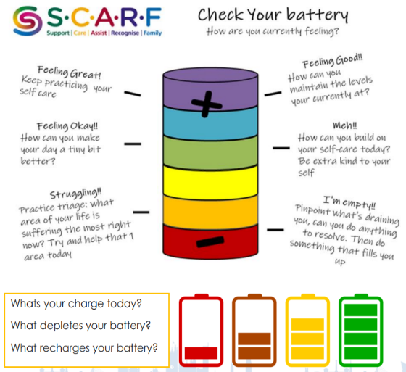

Social Work often involves dealing with competing demands, pressures, different emotions, including hearing and seeing the impact of trauma on others. Certain experiences that can also cause worry and trauma for us. These experiences can gradually and cumulatively have an impact on well-being, making social workers more vulnerable to stress and burnout. Therefore, it is integral to maintain principles and practices of ‘self-care’ to preserve and enhance our own well-being.

A few easy steps to looking after you:

* Take a few minutes in a morning to think about your priorities.
* List what is essential to achieve and park other items.
* Be realistic about what you can accomplish in one day.
* Speak to a peer, a chat can reduce your isolation and help.
* Be honest to those supporting you, they may not know how you may feel.
* Don’t leave it until cracks appear, use your environment and those around you to become the best version of you.
* Most importantly, you are important too, look after yourself so you can continue to care for others. (Taken from Community Care [Stress and experiencing a client's trauma: why self-care for social workers is so important](https://www.communitycare.co.uk/2018/06/01/stress-and-experiencing-a-clients-trauma-why-self-care-for-social-workers-is-so-important/))

There are resources available via the ASC learning and development team including Siobhan Maclean’s “The Social Work Pocket Guide to…: Stress and Burnout” that contains practical tips for social workers to develop professional resilience.

If there are any significant concerns about well-being, both the University and Social Work Development Lead ([Shoyley.chowdhury@nca.nhs.uk](mailto:Shoyley.chowdhury@nca.nhs.uk)) must be notified by the Practice Educator and/or student.

The role of our Northern Care Alliance occupational health service is to provide impartial, independent advice to both employees and managers on all matters relating to workplace health. Should at any stage you require a referral for occupational health input, a decision will be made whether this is best placed for your university services or us as the placement provider to complete.

|  |  |
| --- | --- |
| **13.** | **Useful information (FAQs)** |

## This next section of this welcome pack contains general information and has been designed to answer Frequently Asked Questions (FAQs) on placement. There are also details of key expectations we hold for students whilst with us.

ID Cards

Your Practice Educator will arrange an ID badge and door access cards.

**Reasonable Adjustments**

With your consent the university can share proportionate information about your individual needs, circumstances, and any disabilities you have. This is to ensure we offer and implement reasonable adjustments to ensure you feel supported. Any reasonable adjustments can be reviewed throughout placement.

**Visits**

There is an element of the Practice Educator assessing the capabilities of the student, so any lone working is at their discretion. Students should not be undertaking visits alone i.e., without a qualified worker; unless

* It is not a statutory visit but is direct work with a person.
* The risk assessment for the visit is classed as low risk.
* The student has previously met the people they are visiting with a clear plan being made with the family, student, and the social worker of what the student will be doing.
* The student understands the lone working policy.

**Allocating Cases**

Students cannot have cases allocated solely in their name, these must be joint allocations, and the allocated Practice Educator and/or Off-Site Supervisor, still takes lead responsibility for the work the student completes.

## Consent

People with lived experience of social work should be informed when a student is present to allow the adult and/or carer the choice to partake in student learning without feeling pressurised. This could include obtaining consent to shadow other practitioners undertaking direct work, meetings and discussions. Similarly, people with lived experience would need to provide specific consent to work directly with you as a social work student. Making it clear that you have a primary supervisor who oversees your work, practice and development. It is important to gather consent for direct observations of practice, making it clear to the adult and/or carer that their decision to participate in an observation will not have an impact on their involvement from Adult Social Care or Mental Health services. Explaining that the purpose of the direct observation is solely for assessing and improving your own practice.

## Attendance and Absence

Students need to complete the total 100 (final placement) days on their placement.

Students will need to be flexible and respectful of usual working patterns within the agency and may be required to work shifts, including evenings and weekends.

The pattern of placement attendance will be determined at the Learning Agreement Meeting which will incorporate Reasonable Adjustment Plan if these are required, and any timetabled university attendance.

Students must maintain a record of attendance to be signed off by the Practice Educator. Some universities allow for study leave during the placement which must be agreed in advance with the Practice Educator and must not interfere with required completion dates. These days do not count as placement days.

Please refer to your programme handbook for guidance about any other leave. If applicable this must be agreed with your Practice Educator in advance.

Any absences from placement need to be reported to your Practice Educator or the individual(s) as specified in your learning agreement, at the beginning of the day. Any placement days missed (e.g., through illness) must be made up. You should notify your Practice Tutor. Any interruptions to placement of 3-4 weeks or more must be referred to your University Programme.

**Guidance on the use of social media**

You will need to have awareness of our agencypolicy on the use of social media.

<https://www.northerncarealliance.nhs.uk/application/files/6516/2262/3889/NCAF01820_V1_Social_Media_Maintaining_Confidentiality_Policy.pdf>

Social Work England also issue the following guidance

<https://www.socialworkengland.org.uk/standards/professional-standards-guidance/#technology>

**Dress Code**

Students are required to dress appropriately whilst on placement which may vary according to the setting and may incorporate culturally appropriate dress. Students should check the required dress code with their Practice Educator.

**Behaviour**

Students must consider their approach when engaging in the lives of those using services, considering professional standards and the BASW Code of Ethics. Priority **must** be to put the needs of the people you are supporting before your learning needs and assessment requirements.

Students must ensure they familiarise themselves with the policies and procedures of the organisation and address any difficulties with understanding these with their Practice Educator/On-Site Supervisor. Should any issues arise that you are unable to resolve in this way you should discuss these with your Tutor.

Car parking at place of work

Please check with your Practice Educator regarding parking arrangements at your placement venue. For any other information on NCA Car Parking please contact [carparking@nca.nhs.uk](mailto:carparking@nca.nhs.uk) and more info can be found via [Staff, volunteer and contractor parking :: Northern Care Alliance](https://www.northerncarealliance.nhs.uk/patient-information/car-parking/staff-and-contractor-parking-applications)

**Travel Expenses**

Students on placement in Salford can claim mileage or bus fares for **business purposes** whilst on placement (this does not include mileage/bus fares to and from placement). All journeys must be recorded, and the relevant form is in **Appendix 5**. You will need to keep all car parking and bus fare tickets as proof of purchase for submitting at the end of placement.

**Travelling by car**

Student mileage is paid at 43p per mile. Any students using their car on placement will need to show the following documents to their Practice Educator before starting placement.

* driving licence
* car insurance documentation confirming ‘business use’

Students mustbe insured for business use on their policy, without this level of cover students will be unable to use their cars whilst on placement. This includes any travel connected with placement tasks, regardless of whether passengers are being carried.

Car mileage must be recorded and verified by the Practice Educator at the end of the placement. Each journey must be recorded, along with date, to/from locations, reason for journey and total mileage undertaken.

**Travelling by public transport**

Students should choose the cheapest travel option available whilst on placement (business travel only) [Plan a journey | Transport for Greater Manchester (tfgm.com)](https://tfgm.com/plan-a-journey)

Where possible the same means of transport should be used throughout placement to keep costs to a minimum e.g., students with a monthly bus pass will only be able to use an alternative method of transport (i.e., train/tram) if a bus route is not available. Bus Passes should be purchased on a weekly/monthly basis, for regular business trips (whatever works out the cheapest for number of trips made – only the cheapest option will be reimbursed).

If bus travel is minimal, individual tickets may be used. These should be the cheapest ticket available for the catchment area of placement only. In this instance we would pay the standard Bus Day Saver rate. You can check bus ticket prices here; <https://www.salford.gov.uk/parking-roads-and-travel/public-transport/buses/>

Please ensure that each journey on public transport is recorded (date, area of visit, reason for journey).

**Parking costs for visits/meetings etc.**

To ensure parking costs are kept to minimum, students should check out their journey beforehand and choose the cheapest available parking option. In addition, students should car share where possible (i.e., shadowing Social Workers on visits, in Court etc.). Original parking tickets should also be sent to the address below at the end of the placement. Please ensure you provide a contact number for when your placement has ended.

**How to claim travel expenses/parking costs**

Students can claim travelling expenses at the end of the placement. The payment request form can be found in **Appendix 5**.

|  |  |
| --- | --- |
| Timeframe | Action |
| *Start of placement* | * Student shows Practice Educator driving license and car insurance policy which states business use |
| *During placement* | * Student records all mileage/journeys as above (make sure you retain original public transport tickets and car parking tickets) |
| *End of placement* | Practice Educator verifies student travel expense log as a true reflection of the business travel the student has undertaken and signs/dates this document. Student expense forms need to be sent to [ASCLearningandDevelopment@nca.nhs.uk](mailto:ASCLearningandDevelopment@nca.nhs.uk)   * Student sends the following documents to Student travel expense log * Payment request form * Copies of driving license and car insurance stating business use * Any used passes (public transport)/parking tickets |

**Contingency Planning**

The learning agreement is the key opportunity to discuss and record contingency planning in the event your Practice Educator or On-site Supervisor are either unavailable, on annual leave or absent from work.

**End of Placement**

All students must return their ID cards and any equipment to their Practice Educator.

We want to hear about your experience of placement and will ask you to complete a short survey at the end. This information is then used to take stock of what you felt went well and areas of improvement for the future [https://www.smartsurvey.co.uk/s/QW315U/](https://eur02.safelinks.protection.outlook.com/?url=https%3A%2F%2Fwww.smartsurvey.co.uk%2Fs%2FQW315U%2F&data=05%7C01%7C%7Cd0f8f3a6797a4982a19f08db940d70f3%7C9a12677ec2e94deba58aee1c59ac0161%7C0%7C0%7C638266557663964442%7CUnknown%7CTWFpbGZsb3d8eyJWIjoiMC4wLjAwMDAiLCJQIjoiV2luMzIiLCJBTiI6Ik1haWwiLCJXVCI6Mn0%3D%7C3000%7C%7C%7C&sdata=ln74W0qPdUoD2qeog%2BM%2BP%2F1LJL5Nfe5AD33IIKBHXBY%3D&reserved=0)

|  |  |
| --- | --- |
| **14.** | **Concerns** |

**Concerns about Placement**

Placement is usually an enjoyable learning experience for both student and Practice Educator. However, there are small instances that concerns may arise. If any party should have a concern, they should raise this immediately. Delay in the hope that the problem will resolve itself often leads to an escalation of issues and does not give any party an opportunity to make changes. In the first instance, students and Practice Educators should discuss concerns together. Depending on the nature of the concern, lack of resolution, or need for additional support, the University and the social work development lead, Shoyley Chowdhury ([Shoyley.chowdhury@nca.nhs.uk](mailto:Shoyley.chowdhury@nca.nhs.uk)), should be made aware at the earliest opportunity. Steps to resolving concerns could include supportive discussions, meetings and collaborative action planning with clear targets, responsibilities and required support, all of which are recorded and reviewed.

**Concerns about Discrimination, Victimization or Harassment**

Our organisation strives to supports marginalized students, including ethnicity, gender, disability, age, or the intersectionality of characteristics. If a student believes they have experienced discrimination (directly or indirectly), victimization, or harassment, especially those who hold protected characteristics as defined by the Equality Act 2010, please discuss these at earliest time with your practice educator, the social work development lead Shoyley Chowdhury ([Shoyley.chowdhury@nca.nhs.uk](mailto:Shoyley.chowdhury@nca.nhs.uk)), and/or the University, who will implement remedial actions and provide wellbeing support.

**Concerns about the Organisation (Whistleblowing)**

Challenging unethical practice and reporting concerns is a key element of the professional standards for social workers. There are policies and processes, including whistleblowing (Freedom to Speak Up), in place for students to challenge unsafe behaviours, poor work cultures and organisational wrongdoing, and report concerns openly and safely without fear of adverse consequences. Should you have any concerns about organisational issues, these should be raised in the first instance with either the Practice Educator, team manager and ASC learning and development team. There could be a requirement to incident report the concern(s), depending on the nature of the issue and where it originates from. If it is felt these are not appropriately responded to, then concerns may need to be escalated to the Principal Social Worker Martin Sexton ([martin.sexton2@nca.nhs.uk](mailto:martin.sexton2@nca.nhs.uk)). We would also encourage you to simultaneously discuss these concerns with your university lead.

The link to the relevant policy to raise concerns in the Northern Care Alliance can be found below: <https://www.northerncarealliance.nhs.uk/application/files/6216/7482/1531/NCAHR04423_V1_FTSU_Policy.pdf>

|  |
| --- |
| **Abbreviations** |

**ASC** - Adult Social Care

**BASW** – British Association of Social Work

**GMMH** - Greater Manchester Mental Health

**NCA** - Northern Care Alliance

**OSPE** – Off-Site Practice Educator

**OSS** - On-Site Supervisor

**PCF** – Professional Capabilities Framework

**PE** – Practice Educator

**PSW** – Principal Social Worker

**SCC** - Salford City Council

**SSAB** – Salford Safeguarding Adult Board

**SWEPS** - Social Work England Professional Standards

**Abbreviations an**

**T**

|  |
| --- |
| **Table of Appendices** |

|  |  |
| --- | --- |
| Appendix 1 |  |
| Appendix 2 |  |
| Appendix 3 |  |
| Appendix 4 |  |
| Appendix 5 |  |

|  |
| --- |
| **References** |

Burnham, J. (2013). Developments in Social GGRRAAACCEEESSS: visible-invisible, voiced-unvoiced. In I. Krause (Ed.), Cultural Reflexivity. London: Karnac.

Maclean, S., & Harrison, R. (2015). Social work theory: a straightforward guide for practice educators and placement supervisors. Kirwin Maclean Associates.

Professional Capabilities Framework (2019) BASW

Social Work England Professional Standards (2021)

Social Work England, (2019). Professional Standards Guidance

Social Work England Practice Placements Guidance (2021)

Tedam, P., 2011. The MANDELA model of practice learning. *The Journal of Practice Teaching and Learning*, *11*(2), pp.60-76.

The BASW Code of Ethics for Social Work (2021)

Towey-Swift, K. (2020). The Social Work Pocket Guide to… Reflective Practice: Siobhan Maclean, London: Jessica Kingsley Publishers, 2010

This document is for internal use only and cannot be distributed externally without permission.