Salford Adult ASYE
Mental Capacity Act 2005
Training Workbook

Monday 26 January 2026

This workbook can be used to record your key thoughts and reflections during the session and includes a case study for group discussion in part 4.



Contents

Part 1 – ASYE & the Mental Capacity Act 2005

Part 2 – ASYE Personal Development Planning (PDP) & MCA

Part 3 – Key Thoughts and Reflections on key topics of the session:
- Statutory principles of the MCA (One-Three)
- Assessing Capacity
- Challenges in Practice
- The Best Interests Process (Statutory Principles Four-Five)
- Deprivation of Liberty Safeguards (DoLS) & Court of Protection (CoP)

Part 4 – MCA Case Study

Part 5 – Reading & Resources




Part 1 – ASYE & the Mental Capacity Act 2005

The Assessed and Supported Year in Employment (ASYE) is a 12-month employment-based programme designed to support the professional development, confidence and skills of Newly Qualified Social Workers (NQSWs) in their first qualifying year.
The Mental Capacity Act (2005) is a central piece of legislation that underpins many areas of professional practice expected during ASYE. As NQSWs develop their confidence, knowledge and capabilities, the MCA provides an essential ethical and legal framework for acting and making decisions on behalf of individuals who may lack the mental capacity to make particular decisions for themselves.
During ASYE, all NQSWs are expected to develop and demonstrate a sound understanding of the Act’s five statutory core principles, apply the three‑stage test of capacity, and uphold individuals’ rights to autonomy, least restrictive practice, and best‑interest decision‑making (when required). All social workers must use the statutory principles to protect people who lack capacity and help them take part, as much as possible, in decisions that affect their lives.
Engaging with the MCA in real practice situations allows NQSWs to evidence their development of professional decision-making, legal literacy and critical analysis needed for ethical practice. This also supports NQSWs to build a strong foundation of understanding for safeguarding, empowerment, human rights and person‑centred practice.
Critical reflection and professional practice using the core principles of the MCA enables NQSWs to demonstrate and meet key areas of the two assessment frameworks for ASYE including the:

Professional Capabilities Framework (PCF) - NQSW Level

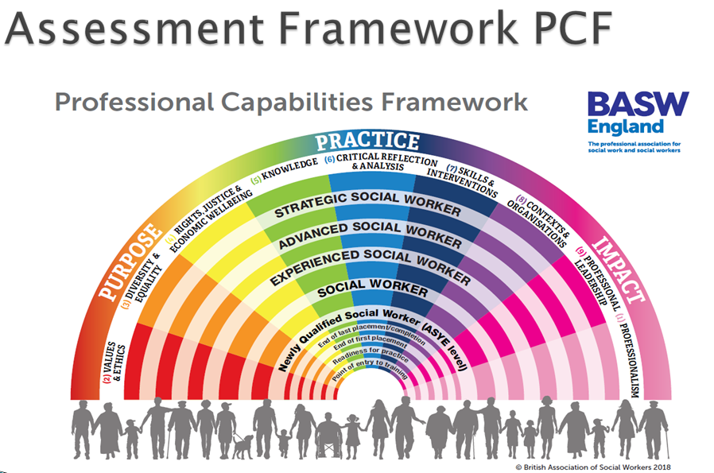

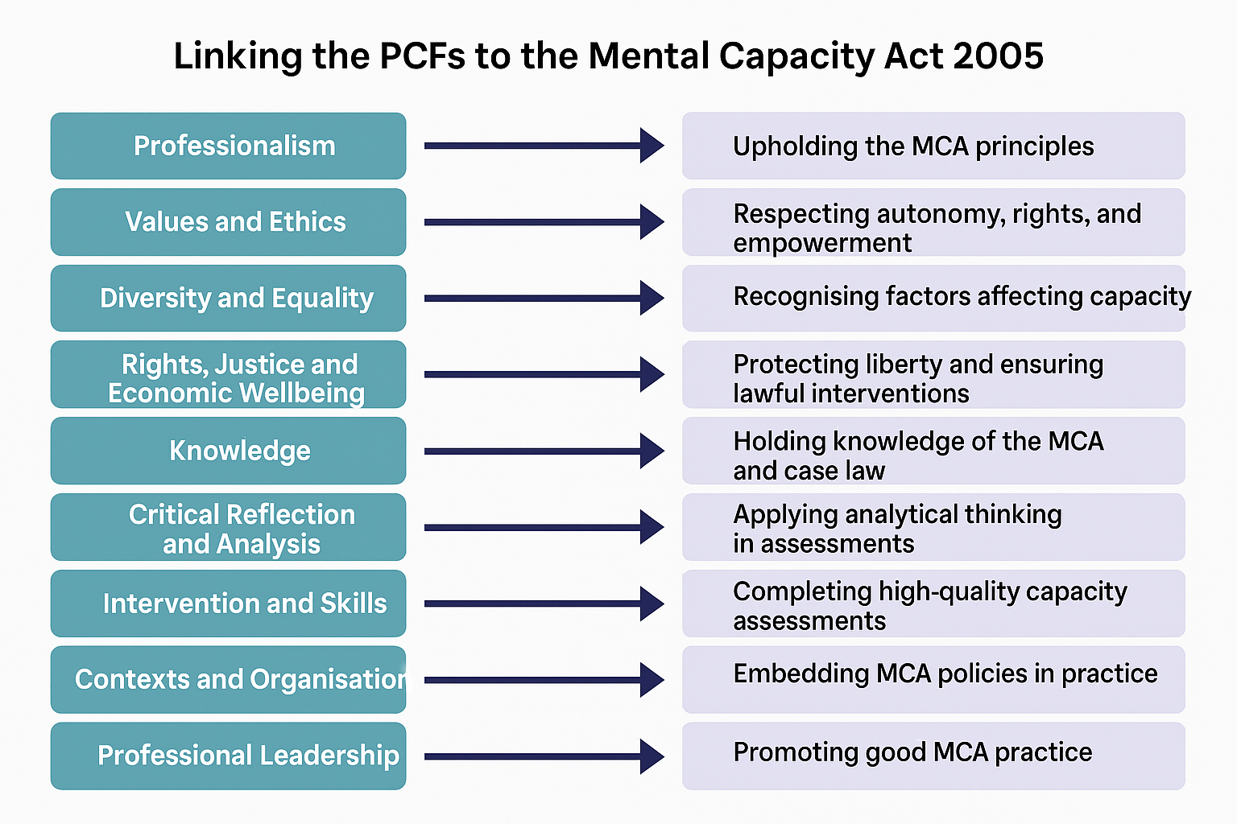

Post Qualifying Standards (PQS)/Knowledge Skills Statement (KSS) for Adults
Each statement sets out what an NQSW should know and be able to do by the end of ASYE

Statement 5 of PQS/KSS) Mental Capacity
Social workers must have a thorough knowledge and understanding of the Mental Capacity Act (MCA) and Code of Practice and be able to apply these in practice. They should always begin from the presumption that individuals have capacity to make the decision in question.
Social workers should understand how to make a capacity assessment, the decision and time specific nature of capacity and hence the need to reassess capacity appropriately. They should know when and how to refer to a Best Interest Assessor.
Social workers must understand their responsibilities for people who are assessed as lacking capacity at a particular time and must ensure that they are supported to be involved in decisions about themselves and their care as far as is possible. Where they are unable to be involved in the decision-making process decisions should be taken in their best interests following consultation with all appropriate parties, including families and carers. Social workers must seek to ensure that an individual’s care plan is the least restrictive possible to achieve the intended outcomes.
Social workers have a key leadership role in modelling to other professionals the proper application of the MCA. Key to this is the understanding that the MCA exists to empower those who lack capacity as much as it exists to protect them. Social workers must model and lead a change of approach, away from that where the default setting is “safety first”, towards a person-centred culture where individual choice is encouraged and where the right of all individuals to express their own lifestyle choices is recognised and valued.

In working with those where there is no concern over capacity, social workers should take all practicable steps to empower people to make their own decisions, recognising that people are experts in their own lives and working alongside them to identify person-centred solutions to risk and harm


Part 2 – ASYE Personal Development Planning (PDP) & MCA

A Personal Development Plan (PDP) is a key component of ASYE. A PDP helps to provide structure, direction, and measurable goals to support the development and confidence for practice. Most PDPs across ASYE will relate to the MCA at some point or another, particularly from 3 months onwards. When setting learning objectives for a PDP, NQSWs should always ensure these are SMART in nature (Specific, Measurable, Achievable, Relevant, Time-bound): please see part for an example. It is important to have sufficient exposure to shadowing, training, joint working and undertake self-directed reading and research, in readiness to carry out statutory practice using the MCA as a legal framework for decision-making. It is essential to prepare for MCA practice through:
- Professional Curiosity
- Legal Literacy
- Understanding of Evidence-Informed practice
- An ability to apply guiding principles hypothetically before practice
- Critical reflection and preparation with supervisor during ASYE supervision

A few example ideas to help form a PDP relating to the MCA could include the following:
Learning Objective | How will I meet the objective, and what support will I need to meet this?
Prepare to carry out my first Mental Capacity Assessment.  Build my knowledge and confidence to use the MCA 2005 and the statutory guiding principles, ensuring I take all practicable steps possible, to support the adult to make the specific decision in hand.  Accurately record the assessment to show my rationale and professional decision-making. | - Shadow different colleagues and reflect on the observations to make sense of these experiences  - Discussions in supervision to plan and prepare  - Read examples of MCA documents to build recording skills  - Accessing relevant MCA training and sessions (Mandatory training, E Learning, ASYE sessions, workshops, use of Research in Practice)  - Familiarisation of the five statutory principles  - Understanding the three-stage test of capacity  - Reading summarising key points from the MCA code of practice  - Critical reflection, using and applying different theories, models, values and ethics when completing assessment of capacity  - Reflecting on possible practice issues and challenging own biases  - Using support of supervisors, peers, colleagues and drawing on knowledge of other experts.  - Understanding when processes for Best Interests apply  - Understanding the roles of Independent Mental Capacity Advocates (IMCAs) and when this could apply.  - Reading MCA case law to build knowledge and understanding

Part 3 – Thoughts and Reflections on key topics in the MCA session:

You can use this section of the workbook to record your thoughts and reflections from the MCA session, including any peer reflections
Statutory principles of the MCA (One to Three)
Key topics:
- Principle One - A person must be assumed to have capacity unless it is established that they lack capacity.
- Principle Two - A person is not to be treated as unable to make a decision unless all practicable steps to help them to do so have been taken without success.
- Principle Three- A person is not to be treated as unable to make a decision merely because they makes an unwise decision.

Assessing Capacity
Key topics:
- Four elements: Understand, retain, use/weight up and communicate
- Relevant Information: nature, reason, consequence, salient
- Three-stage tests: functional, diagnostic and causative nexus

Challenges in Practice

The Best Interests Process
Key topics
- Principle Four - An act done, or decision made, under this Act for or on behalf of a person who lacks capacity must be done, or made, in his best interests.
- Principle Five- The act is done, or the decision is made, regard must be had to whether the purpose for which it is needed can be as effectively achieved in a way that is less restrictive of the person’s rights and freedom of action
- Decision-maker for Best Interests?
- Role of Lasting Power of Attorney for Health and Welfare
- Role of Independent Mental Capacity Advocate (IMCA)

Deprivation of Liberty Safeguards (DoLS) and Court of Protection (CoP)
Key Topics
- Acid Test – ‘Continuous supervision and control’ and ‘not free to leave’
- Cheshire West Judgement (2014)


Part 4 – MCA Case Study

Case study: David
David is 45 years old, he loves to go for long walks, listens to rock music every day and loves to support his local football team, Tottenham Hotspur. David has a great sense of humour.
David is autistic and has learning disabilities. He lives in a supported living flat with two other people. David has a small team of people who help him with cooking, reminders to get dressed and attend appointments and for helping him to understand when he is unwell and needs to see a doctor.
David does not like to see any doctors, he once had a bad reaction to a routine vaccination in a GP surgery and will refuse to enter the building, so appointments are made over the phone, and a GP will visit his home if he is very unwell.
One night David wakes up and starts talking loudly. The care team overnight consists of one sleeping member of staff and one waking. The waking member of staff goes to see David and manages to gently touch his forehead and notices he is hot, she also notices he is biting his hand, something he has not done for some time.
The member of staff contacts the out-of-hour GP, he advises that they make an appointment for the morning and to contact them if he becomes worse.
David starts to pace his room and talking even more loudly and the member of staff notices that he is hunching more than usual, she attempts to look at him, but he will not sit down, she decides to call an ambulance.
The ambulance team recommend that David be taken in for further tests, as soon as David hears this he starts to pace repeating ‘no, no, no no’. The ambulance crew discuss with David’s mum, on the phone his refusal. David’s mum says that his current behaviour is not like him, that he is anxious about hospitals, but she is worried that he needs to go.
The ambulance team talk to David about needing to take him in an ambulance, explaining what will happen and why he needs to go. David’s response continues to be ‘no, no, no’.

Questions
- How should we assess David’s capacity to make decisions about his care needs and whether he should go to hospital (principles 1 – 3)?
- How should we make a decision about what is in David’s best interests (principles 4 & 5)?

Summary
Note down your own three takeaway messages from today. List as an agenda to share with your ASYE assessor for your next supervision.

1.

2.

3.

Part 4 Reading and Resources

Cheshire West & Chester Council v P | 39 Essex Chambers
Decision-making under the Mental Capacity Act 2005 | Research in Practice
Draft MCA Code of Practice: summary - GOV.UK (www.gov.uk)
Independent Mental Capacity Advocacy (IMCA) - Mind in Salford
Mental-capacity-act-code-of-practice.pdf
Mental Capacity Act (MCA) - SCIE
Mental Capacity Resource Centre | 39 Essex Chambers
Mental Capacity Act 2005 Resource and Practice Toolkit
https://www.salfordappp.co.uk/wp-content/uploads/2024/04/Advocacy-Guidelines.pdf
SMART PDP Example
Specific
I will deepen my knowledge of the Mental Capacity Act (2005) by reading the Mental Capacity Act Code of Practice and attending the RIPFA learning session on ‘supporting practice around mental capacity’ Mental capacity in social care | Research in Practice. I will focus on understanding the three-stage test of capacity (diagnostic, functional and causative nexus) and how to apply it in practice. I will shadow at least two colleagues completing mental capacity assessments with people they are supporting

Measurable
Complete one structured training session on mental capacity assessments.
Read and summarise the Mental Capacity Act Code of Practice
Work through two case studies applying the two-stage functional test and discuss in supervision
Shadow at least two colleagues when they complete mental capacity assessments

Achievable
Access online session from RIPFA, put session detail in calendar as a reminder
Use my next two protected study days to complete the session and complete the reading and case study exercises
Discuss my learning and reflections in my supervision session on 23rd March, 8 weeks from now

Relevant
Developing competence in mental capacity assessments is directly linked to my role as a social worker.
It ensures I can safeguard individuals’ rights and make lawful, ethical decisions in practice.
Builds confidence before undertaking a real assessment.

Time-bound
By the end of 8 weeks, I will:
Complete training and reading.
Shadow two colleagues completing capacity assessments
Reflect on learning in supervision and update my PDP.

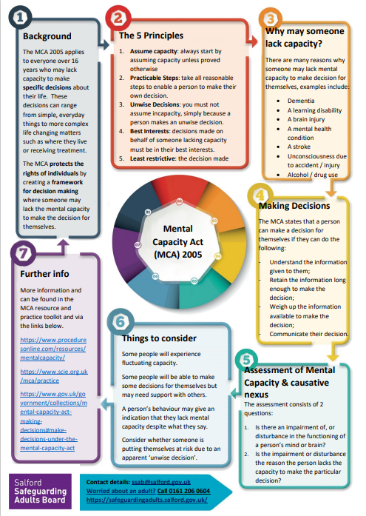
Used from: 7 Minute Briefings and Factsheets | Salford Safeguarding Adults Board

