
Salford Adults
Social Work Student Safeguarding Session

Thursday 2 April 2026

This is a workbook of activities that you can use to record your key thoughts and reflections during the session.



Session Aims & Objectives

Part 1 – Introduction to safeguarding Legal Frameworks

Part 2 – Core Principles for Safeguarding

Part 3 – Salford Safeguarding Adult Board
(No Activity – Info Only)

Part 4 – Referrals and Enquiry Procedures



Initial Thoughts
Answer the following questions:
What comes to mind when you think of the word ‘safeguarding’?
How can you develop your knowledge and skills to build confidence in safeguarding practice?
Which PCFs relate to safeguarding? (Circle the diagram at the bottom)
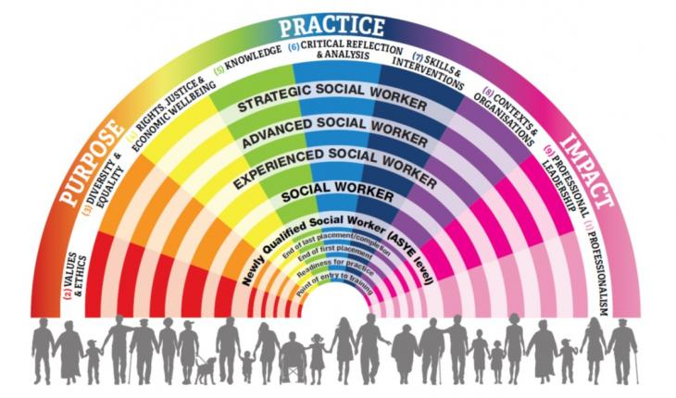


Part 1
Safeguarding Legal Frameworks
Activity 1 Read the following safeguarding referral
Summary of concern (Referral): | Adult vulnerability referral received from Greater Manchester Police.  Mr A is in his 40s, and lives in a housing association flat, with little family contact. His mental health is relatively stable, following a previous period of hospitalisation and he has visits from a mental health support worker.  Mr A’s physical health has begun to deteriorate, and he appears to be struggling to manage certain day-to-day tasks, such as preparing meals, washing, and dressing himself (presenting dishevelled and underweight). The property is cluttered with personal items, boxes, newspapers, and bags of rubbish.  Mr A rarely goes out, but he allows people into his accommodation because of his loneliness. The police were alerted by Mr A’s neighbours to several domestic disturbances. His accommodation had been targeted by several local people and he had become subject to verbal and financial abuse. Although Mr A initially insisted, they were his friends, he did indicate he was frightened and anxious.
Has consent to share information been given by the person at risk or their advocate/representative? | No
If no, why not? | Mr A does not want social services involved because he feels it will only make his situation worse. He feels he can cope and keep himself safe.

Does the Section 42 safeguarding duty apply? Circle Yes or No
If yes, how do the three conditions apply. Write a few comments under each header.
(a)has needs for care and support (whether or not the authority is meeting any of those needs)

(b)is experiencing, or is at risk of, abuse or neglect, and

(c)as a result of those needs is unable to protect himself or herself against the abuse or neglect or the risk of it.


Activity 2 Take a look at the categories of neglect and abuse
Do you think there are any categories missing?
Do we hold any preconceptions (personally or societally) about these categories of abuse or neglect, that could lead to bias? For example, only older people experience financial abuse…
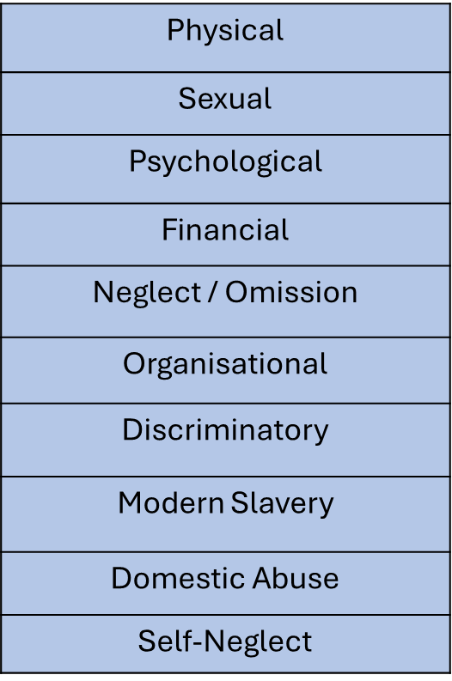

Activity 3 Other legal frameworks
Aside from the Care Act 2014, what other legal frameworks apply to safeguarding, briefly including how and why?
Write a list below


Part 2
Core Principles for Safeguarding
Activity 4 Six safeguarding principles
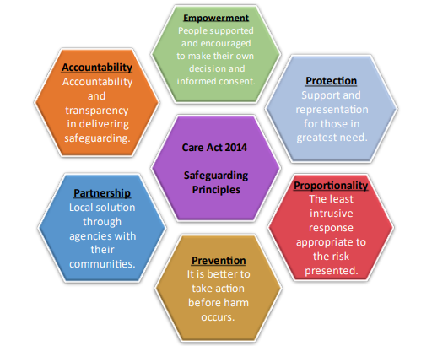
Choose one principle and detail the potential “I” statement in the words of the adult and what it would feel like in action for them

Activity 5 Professional Curiosity and Reflective Practice
What does professional curiosity mean to you? List a few theories, models or approaches that can be used to support good safeguarding practice.

Part 4
Referrals and Enquiries
Activity 6 Read the following safeguarding referral
Answer questions a-e on the following pages
Summary of concern (Referral): | Maryam is a 30-year-old lady who lives at home with her boyfriend Steve. Maryam has a diagnosis of spina bifida which results in difficulties weightbearing and walking, she has various aids and adaptations in her property and uses a self-propelling wheelchair. Maryam also has a diagnosis of emotionally unstable personality disorder (EUPD), she struggles regulating her emotions, experiences feelings of heightened stress and at times paranoia.  Maryam receives visits from care staff twice a day who assist her with personal care, dressing, meals and occasionally help her to empty her suprapubic catheter. These care services are arranged through the Local Authority. Maryam recently disclosed to one of her carers that Steve often screams, shouts, and becomes angry towards her. Maryam feels Steve is stressed in his caring role. Also, Steve is worried about the number of bills they need to pay, he works part time and wishes for full time employment. The carer also notices a bruise to Maryam’s left upper arm which appears to be the shape of a handprint; however, Maryam is adamant this happened after she ‘bumped’ herself. Maryam said there are times she feels pressurised to have sex with Steve, that he will leave her if she says no.  Maryam has a hearing impairment and can struggle to make her views and feelings known, particularly if she feels overwhelmed. She has a close friend called Becky who visits on a weekly basis and takes her to a local community group to do arts and crafts, which Maryam thoroughly enjoys as it gets her out of the house and breaks the tension with Steve. The care worker has noticed several empty alcohol bottles around the house; there is limited food to prepare meals, and prescribed medication appears to be missing. Maryam last had a social care review of her care and support needs 4 months ago and there is no allocated social worker.
Has consent to share information been given by the person at risk or their advocate/representative? | After much convincing, Maryam provided the care worker consent to raise this safeguarding referral, however Maryam’s worried about what will happen next and if anyone can help her.

- What are the areas of concern and how does the safeguarding duty apply?

- has needs for care and support?
- is experiencing, or is at risk of, abuse or neglect, and?
- as a result of those needs is unable to protect self against the abuse or neglect or the risk of it?

- What form of enquiry could this potentially be? (Single agency, multiple agencies or criminally led investigation)

- If this is initially a single agency enquiry, how would you arrange a welfare visit to see Maryam and how would you approach conversation with her?

- Is there any reason to doubt Maryam’s capacity to consent to safeguarding enquiries? (are there are any other areas of decision-making to consider)

- What scope of enquires would you undertake; what information are you trying to ascertain?

Activity 7
Using the same example answer questions f-i on the following pages
- What safeguarding measures could potentially support Maryam. What could reduce the potential risk of abuse or neglect? (incl. protective factors, strengths-based approach, carers needs)

- What key agencies might be involved that you could you liaise with?

- Is there a need for safeguarding plan and/or risk assessment, what would be the benefits, and would Maryam need to consent?

- How would you maintain the key principles of safeguarding when working with Maryam?
Choose from one of the following:
- Principle of Making Safeguarding Personal
- Care Act, Section 1 Well-being
- 6 Principles of safeguarding empowerment, partnership, accountability, prevention, proportionate and protection

Activity 8 Summary
Note down your own three takeaway messages from today.

1.

2.

3.

